

Elga hybrid heat pump

**Installer's Manual**

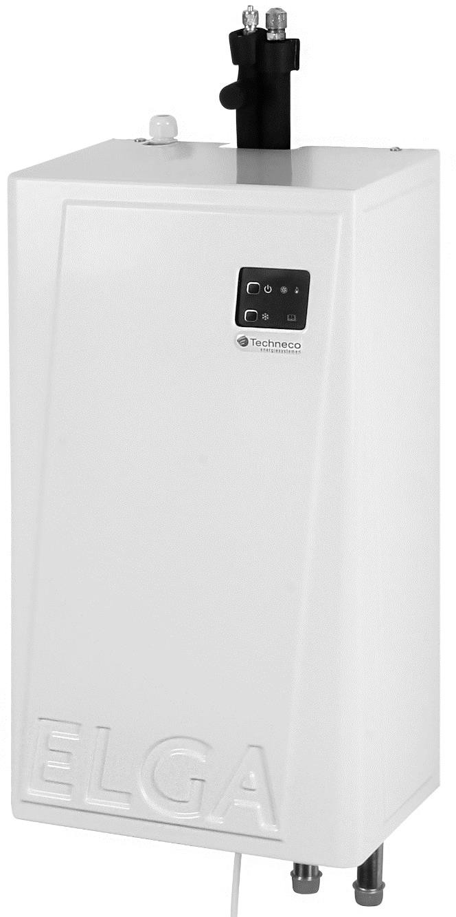

60527V16-4

9-7-2019

#### Associated with firmware version 16.0 and higher

**Table of contents**

 [Introduction4](#_TOC_250104)

* 1. [Spare parts4](#_TOC_250103)
  2. [Necessities4](#_TOC_250102)

[Technical data5](#_TOC_250101)

[System Selection6](#_TOC_250100)

[Installation indoor unit7](#_TOC_250099)

* 1. [Mounting indoor unit7](#_TOC_250098)
  2. [Hydraulically connect Elga indoor unit7](#_TOC_250097) 
     1. [Hydraulic system selection7](#_TOC_250096)
     2. [Hydraulic parallel connection of Elga indoor unit and central heating boiler7](#_TOC_250095)
     3. [Hydraulic in series connection of Elga indoor unit and district heating8](#_TOC_250094)
  3. [Points of attention when hydraulically connecting the Elga indoor unit8](#_TOC_250093) 
     1. [Method of parallel connection Elga and central heating boiler8](#_TOC_250092)
     2. [Hydraulic supply lines8](#_TOC_250091)
     3. [Positions check valves when connecting](#_TOC_250090)  in parallel  [Elga8](#_TOC_250090)
     4. [Hydraulic connections in combination with an open distributor9](#_TOC_250089)
     5. [Engine operated two-way valve when using district heating9](#_TOC_250088)

[Installation outdoor](#_TOC_250087)  [unit10](#_TOC_250087)

* 1. [Installing the outdoor](#_TOC_250086)  [unit10](#_TOC_250086)
  2. [Electrical connection of the outdoor](#_TOC_250085)  [unit10](#_TOC_250085)
  3. [Connecting the refrigerant side of the outdoor](#_TOC_250084)  [unit10](#_TOC_250084)

[Connection of boiler and thermostat11](#_TOC_250083)

* 1. [Thermostat compatibility11](#_TOC_250082) 
     1. [Heating11](#_TOC_250081)
     2. [Automatic cooling11](#_TOC_250080)
     3. [Weather dependent control11](#_TOC_250079)
  2. [Boiler compatibility11](#_TOC_250078)

 [Interface12](#_TOC_250077)

* 1. [Display12](#_TOC_250076)
  2. [Thermostat12](#_TOC_250075)
  3. [LEDs and DIP switches on Elga circuit](#_TOC_250074)  [board13](#_TOC_250074)

[Explanation dipswitches14](#_TOC_250073)

 [Embedding15](#_TOC_250072)

* 1. [Set up thermostat15](#_TOC_250071)
  2. [Elga parallel hydraulic adjustment (K1 to K14) 15](#_TOC_250070)
  3. [Elga and open distributor serial hydraulic adjustment (SV1 to SV7 and K15) 17](#_TOC_250069)

[General scheme19](#_TOC_250068)

* 1. [Introduction scheme19](#_TOC_250067)
  2. [Description control](#_TOC_250066)  [strategy19](#_TOC_250066)
  3. [Central heating boiler/district heating](#_TOC_250065)  [control19](#_TOC_250065) 
     1. [Central heating boiler OpenTherm19](#_TOC_250064)
     2. [Central heating boiler/district heating on/ off19](#_TOC_250063)
     3. [Tap water19](#_TOC_250062)
     4. [Control/settings of the boiler19](#_TOC_250061)
  4. [Refrigeration company20](#_TOC_250060)
  5. [Outside temperature below outside temperature limit heat](#_TOC_250059)  [pump20](#_TOC_250059)
  6. [Afterrunning times and pump](#_TOC_250058)  [circuits20](#_TOC_250058)
  7. [External outdoor sensor20](#_TOC_250057)
  8. [Additional contacts (cable for extra functionality) 21](#_TOC_250056) 
     1. [Fault contact (32 and 33) 21](#_TOC_250055)
     2. [Summer/winter contact (23 to 25) 21](#_TOC_250054)
     3. [Locking or release heating and cooling (28 to 31) 21](#_TOC_250053)
     4. [External pump (19 and 21) 21](#_TOC_250052)

[Thermostatic control22](#_TOC_250051)

* 1. [The room](#_TOC_250050)  [thermostat22](#_TOC_250050)
  2. [Switching on central heating boiler or district](#_TOC_250049)  [heating22](#_TOC_250049)
  3. [Reduced desired room](#_TOC_250048)  [temperature22](#_TOC_250048)
  4. [Thermostat with automatic cooling23](#_TOC_250047)
  5. [Thermostat without cooling](#_TOC_250046)  [support23](#_TOC_250046)
  6. [Heating lines/ heating control behaviour23](#_TOC_250045)

 [Weather-dependent control24](#_TOC_250044)

* 1. [Adjustments to the installation for use with weather-dependent control24](#_TOC_250043)
  2. [Switch on central heating boiler or district](#_TOC_250042)  [heating24](#_TOC_250042)
  3. [Heating control24](#_TOC_250041)
  4. [Cooling25](#_TOC_250040)
  5. [Weather dependent + zone control/after](#_TOC_250039)  [adjustment25](#_TOC_250039)
  6. [Setting up Honeywell Touch thermostat25](#_TOC_250038)

[Fault reports26](#_TOC_250037)

* 1. [Outside temperature remains 0°C on thermostat26](#_TOC_250036)
  2. [Fault message of the circulation](#_TOC_250035)  [pump26](#_TOC_250035)
  3. [Fault codes Elga27](#_TOC_250034)
  4. [Fault codes Toshiba-print28](#_TOC_250033)

 [Maintenance29](#_TOC_250032)

[Warranty and service29](#_TOC_250031)

* 1. [Standard warranty29](#_TOC_250030)
  2. [Warranty Registration Form29](#_TOC_250029)
  3. [Service and fault](#_TOC_250028)  [notification29](#_TOC_250028)

[Parts and article](#_TOC_250027)  [number30](#_TOC_250027)



[Dimensions31](#_TOC_250026)

[Electrical diagram + resistors NTC](#_TOC_250025)  [sensors32](#_TOC_250025)

[Installation diagrams33](#_TOC_250024)

[K1OpenTherm central heating boiler + Honeywell Touch modulation thermostat33](#_TOC_250023)

[K2On/off central heating boiler + Honeywell Touch modulation thermostat34](#_TOC_250022)

[K3OpenTherm central heating boiler + other OpenTherm thermostat35](#_TOC_250021)

[K4On/off central heating boiler + other OpenTherm thermostat36](#_TOC_250020)

[K5OpenTherm central heating boiler + weather-dependent](#_TOC_250019)  [control37](#_TOC_250019)

[K6On/off central heating boiler + weather-dependent](#_TOC_250018)  [control38](#_TOC_250018)

[K7OpenTherm](#_TOC_250017)  [central heating boiler + zone control](#_TOC_250017)  [general39](#_TOC_250017)

[K8On/off central heating boiler + zone control](#_TOC_250016)  [general40](#_TOC_250016)

[K9OpenTherm central heating boiler + zone control Honeywell HCE2041](#_TOC_250015)

[K11 OpenTherm central heating boiler + zone control Danfoss CF2+ 42](#_TOC_250014)

[K13 OpenTherm central heating boiler + zone control Honeywell EvoHome43](#_TOC_250013)

[K14 On/off central heating boiler + zone control Honeywell EvoHome44](#_TOC_250012)

[K15 central heating boiler + Elga with open distributor in series45](#_TOC_250011)

[SV1 District heating + Honeywell Touch modulation thermostat46](#_TOC_250010)

[SV2 District heating + other OpenTherm thermostat47](#_TOC_250009)

[SV3 District heating + weather-dependent control48](#_TOC_250008)

[SV4 District heating + zone control general49](#_TOC_250007)

[SV5 District heating + zone control Honeywell HCE2050](#_TOC_250006)

[SV6 District heating + Zone control Danfoss CF2+ 51](#_TOC_250005)

[SV7 District Heating + Zone Control Honeywell EvoHome52](#_TOC_250004)

[Elga and boiler with separate boiler for tap water (hydraulic ) 53](#_TOC_250003)

[Parameter list Honeywell Touch](#_TOC_250002)  [thermostat54](#_TOC_250002)

* 1. [Thermostat installer menu54](#_TOC_250001)
  2. [Parameters menu Elga54](#_TOC_250000)

|  |  |
| --- | --- |
| **Supplier**  Techneco Energiesystemen BV Kleveringweg 9  NL-2616 LZ Delft  T: 015-2191000  E.: [info@techneco.nl](mailto:info@techneco.nl)  W: [www.techneco.nl](http://www.techneco.nl/) | **Disclaimer**  This document is subject to change and is subject to change without notice. Although the utmost care has been taken in compiling this document, it cannot be guaranteed that the information is complete, up-to-date and/or accurate. No rights can be derived from this document. |

|  |
| --- |
|  |
| Old electrical and electronic devices often contain valuable materials. Therefore , never place a discarded appliance with the ordinary waste. Always hand in the device at a local collection depot for electricity.  sche and electronic equipment. |

# Introduction

## Components

With the delivery of the Elga heat pump you will receive the following parts.

|  |  |
| --- | --- |
|  |  |
| Elga indoor unit | Toshiba outdoor unit |

In the box of the indoor unit there are also the following pieces / parts.

|  |  |  |  |  |
| --- | --- | --- | --- | --- |
| http://shop.cvkoopjes.nl/19884-large/honeywell-chronotherm-touch-modulation-klok-thermostaat.jpg | C:\Users\kcornelissen\Pictures\manual.png | C:\Users\kcornelissen\Pictures\manual.png |  |  |
| 1x OpenTherm room thermostat | 1x Installer guidance | 1x User manual | 2x Check valves (1") | 2xNTC sensors (10 kΩ) |

## Supplies

The number of parts required for the installation of an Elga depends on the current installation, location of the outdoor unit and the preference of the installer. In general, the following additional parts are needed.

* + - Confirmation
      * 3 x Mounting material for the indoor unit on the wall. Depending on the type of wall, use the right screws and plugs.
    - Hydraulic (are there 2 mogelijkheden, see chapter [4.2.1](#_bookmark2) for more information)
      * Parellel Hotels
        + Central heating pipe (22 mm) (for connection between Elga and central heating system)
        + 2 x Tee (22 mm)
        + 4 x Point piece pinch (1"-22 mm)
        + Fitterstape
      * Open distributor in series
        + Central heating pipe (22 mm) (for connection between Elga and central heating system)
        + 1 x 1" open distributor
        + 1 x Balancing valve (district heating)
        + 4 x Point piece pinch (1"-22 mm)
        + Fitterstape
    - Refrigeration technology
      * Refrigerant pipe 1/4" and 3/8" (for connection between Elga and outdoor unit)
      * Required (flare) couplings
    - Electric
      * Wall socket door (with 1.5 kW electrical power freely available on the relevant group)
      * Four-wire cable (4\*1.5 mm2) (for power supplying outdoor unit from Elga)
      * Two-wire weak current signal cable (minimum 0.14 mm2) for the connection between Elga and the room thermostat
      * Two-wire weak current signal cable (minimum 0.14 mm2) for the connection between Elga and the boiler
      * The optional extra outer sensor must be wired three-wire shielded

# Technical data

|  |  |  |
| --- | --- | --- |
| **Accomplishments** | **ELGA with Toshiba RAV-SM304** |  |
| **Heating capacity (A12/W35)** | 4,9 | Kw |
| **Heating capacity (A10/W35)** | 4,6 | Kw |
| **Heating power (A7/W35)** | 4,2 | Kw |
| **Heating capacity (A2/W35)** | 3,2 | Kw |
| **Heating capacity (A7/W45)** | 3,8 | Kw |
| **Heating power (A-7/W35)** | 2,4 | Kw |
| **Cooling capacity, variable** | 2,5 | Kw |
| **COP heating (A7/W35)\*** | 4,6 | - |
| **COP heating (A7/W45)\*** | 3,4 | - |
| **COP heating (A-7/W35)\*** | 2,6 | - |
| \*nominal values measured according to EN14511 test frequency 50Hz | | |

|  |  |  |
| --- | --- | --- |
| **Electric** |  | |
| **Voltage (nominal)** | 1f / 50Hz / 230V | - |
| **Heating electrical power (nominal)** | 1.060 | W |
| **Heating compressor current intake (nominal)** | 4,6 | A |
| **Heat compressor current intake (maximum)** | 6,0 | A |

|  |  |  |
| --- | --- | --- |
| **Outdoor unit details** |  | |
| **Manufactured** | Toshiba | - |
| **Type** | RAV-SM304 | - |
| **Sound pressure level at 5 meters (full load, free field setup)** | 47 | dB(A) |
| **Sound power level (nominal)** | 62 | dB(A) |
| **Dimensions H x W x D** | 550 x 780 x 290 | Mm |
| **Net weight** | 33 | Kg |
| **Air flow maximum** | 1.800 | m3/h |
| **Type of connections** | Flare | - |
| **Diameter pipe refrigerant liquid** | 1/4 | inch |
| **Diameter pipe refrigerant gas** | 3/8 | inch |
| **Minimum pipe length** | 2 | m |
| **Maximum pipe length without refilling** | 15 | m |
| **Maximum pipe length with refilling** | 20 | m |
| **Refilling for pipes longer than 15m** | 20 | g/m |
| **Maximum height difference** | 10 | m |
| **Electric with indoor unit** | 4 x 1.5 | MM2 |
| **Refrigerant** | R410A | - |
| **Refrigerant filling** | 0,8 | Kg |

|  |  |  |
| --- | --- | --- |
| **Indoor unit details** |  | |
| **Manufactured** | Techneco Hotels | - |
| **Dimensions H x W x D** | 550 x 310 x 200 | Mm |
| **Net weight** | 20 | Kg |
| **Thermostat connection** | Opentherm | - |
| **Boiler connection** | on/off or OpenTherm | - |
| **Hydraulic connections central heating system (2x)** | 22 | Mm |

*All data and values are subject to change.*

# System selection

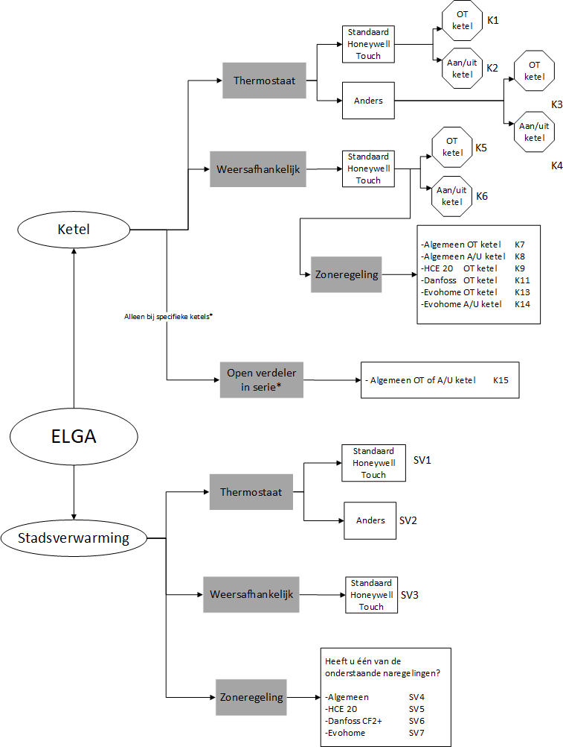

[Figure 3-1](#_bookmark1) shows a flowchart that offers the possibility to easily and quickly make a choice in the system design and the corresponding wiring diagram. For more information and explanation of the installation, please refer to the chapters referred to in the flow diagram. These chapters can be found at the back of the manual.

⚠ **Please note!**  Is a hydraulic separation used for district heating? Then also add an overflow and expansion provision to the installation if they are not yet ready.

##### Figure 3-1

\*see section [6.2](#_bookmark14) for more information

# Installation indoor unit

## Mounting indoor unit

Remove the screws on the top and bottom of the plastic cover. Then pull the plastic cover towards you. In the back plate of the Elga indoor unit there are two keyholes. These are for attaching the back plate to the wall.

Make sure you have two attachment points (diameter max. 5 mm) level at 175 mm apart, at the place where the Elga should be hung. Hang the indoor unit here with the keyholes over it and secure the back plate at the bottom with one screw (diameter max. 6 mm). For this there is a hole in the back plate.

Check that the indoor unit is solidly attached. The Elga should always be attached upright. Keep in mind that there must be enough space around the indoor unit of the Elga to be able to perform work on the indoor unit. [Figure 4-1](#_bookmark3) shows the minimum space around the indoor unit.

## Hydraulic connection Elga indoor unit

The Elga can be hydraulically connected in two ways: parallel or with open distributor in series. Some central heating boilers are best connected to the Elga in combination with an open distributor in series. Chapter [4.2.1](#_bookmark2) describes the hydraulic choice.

##### Hythraulic system selection

**Figure 4-1**

The central heating boiler is connected to the Elga in parallel as standard. District heating is connected as standard with an open distributor in series. In a number of situations we recommend not to connect the central heating boiler in parallel but with an open distributor in series.

##### Central heating boiler parallel to the Elga

Standard

##### District heating with open distributor in series with the Elga

Standard

##### Central heating boiler with open distributor in series with the Elga

Only necessary for specific central heating boilers: See the following properties:

* + - * the modulation range of the circulation pump in the boiler cannot be set, or can only be set by the manufacturer .
      * the tap water three-way valve is in the supply and the resting position is variable (see table [Table 4-1](#_bookmark8) for more information)

A list of these specific boilers can be found in the Elga's design manual. This can be found on our website [https://techneco.n](https://techneco.nl/) [l](https://techneco.nl/) or go directly to <https://techneco.nl/documentatie/elga-hybride-warmtepomp/> and select the elga design manual (incl. compatibility list) under "documents for the installer".

##### Hydraulic parallel connection of Elga indoor unit and central heating boiler

This chapter shows the hydraulic connection of an Elga indoor unit with a central heating boiler. A short step-by-step plan describes how the Elga should be connected. **For important considerations, see chapter** [**4.3.**](#_bookmark4)

* + - * **Step 1:** Determine the system design and select the appropriate wiring diagram in the attachment using the flowchart in chapter [3.](#_bookmark0)
      * **Step 2:** Make the CV system printless and tap it (partially). Make the connections in the piping between the Elga and the central heating boiler; place the check valves in the direction indicated in the piping if the Elga and boiler are connected in parallel. Make use of the relevant wiring diagram in the annex.

⚠ **Please note!**  The location of the non-return valve differs per boiler, see chapter [4.3.3](#_bookmark6) for explanation.

* + - * **Step 3:** Place valves in the central heating pipes to make maintenance and work on the Elga indoor unit easier. Place an extra overflow and expansion tank at the Elga. This step is not mandatory but is recommended by Techneco.
      * **Step 4:** Fill the central heating system to a pressure of approximately 2 bar in cold condition. Make sure the radiators are open .
      * **Step 5:** Unscrew the system via the central heating boiler, radiators and the Elga indoor unit. In the piping of the Elga indoor unit, there is a valve for venting on the upper pipe just above the circulation pump.
      * **Step 6:** Check the leak tightness of the system.

##### Hydraulic in series connection of Elga indoor unit and district heating

This chapter shows the hydraulic connection of an Elga indoor unit with district heating. A short step-by-step plan describes how the Elga should be connected. **For important considerations, see chapter** [**4.3.**](#_bookmark4)

* + - **Step 1:** Create the system setup and select the appropriate wiring diagram in the attachment using the flowchart in Chapter [3.](#_bookmark0)

⚠ **Please note!**  Always place the Elga in series with the district heating for proper operation.

* + - **Step 2:** Slur the district heating and (partially) drain the central heating system. Make the connections in the piping between Elga, open distributor and district heating. Place (if not present) an engine-operated two-way valve in the supply pipe of the district heating. Make use of the relevant wiring diagram in the annex.
    - **Step 3:** Vent the system via the radiators and the Elga indoor unit. In the piping of the Elga indoor unit there is a valve for venting on the upper pipe.
    - **Step 4:** Check the leak tightness of the system.

## Points of attention when hydraulically connecting the Elga indoor unit

In this chapter , important points of attention when hydraulically connecting the Elga indoor unit and a central heating boiler or district heating are shown.

##### Method of parallel connection Elga and central heating boiler

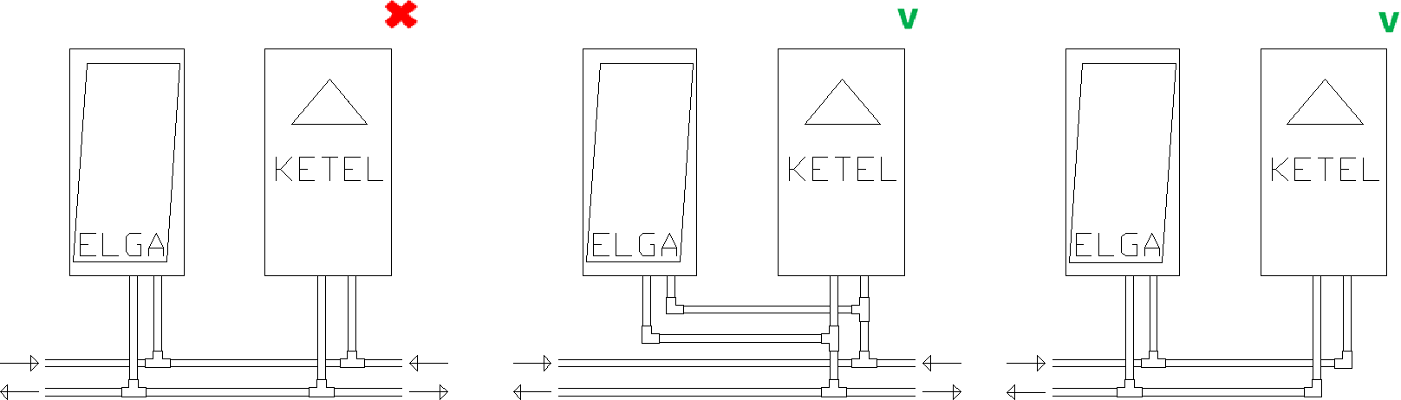When using the Elga in combination with a central heating boiler, the devices are connected in parallel as standard. It is important that the hydraulic lines come together before a subdivision to the heat emission system is made. [Figure 4-2](#_bookmark5) shows how it should not be done and how it can be done with parallel connection of the Elga and the central heating boiler.

##### Figure 4-2

##### Hydraulic supply lines

Regardless of the brand or type of boiler, it must be ensured that the supply pipes of the boiler and Elga are perpendicular to each other. If they have an angle of 180°, flow disturbances can occur on the Elga or boiler. See in [Figure 4-3](#_bookmark7) how it should not and can not be done. When embedding, make sure that the circulation pumps of the Elga and boiler are properly adjusted to each other, so that simultaneous operation is possible.

##### Figure 4-3

##### Positions check valves when connecting in parallel Elga

For the correct operation of both Elga and central heating boiler, two check valves are included. These are used when there is a parallel arrangement of Elga and central heating boiler. The position of the check valves is important for proper operation and depends on the central heating boiler used.

##### The non-return valve of the Elga is always mounted in the supply of the Elga. The position of the non-return valve of the central heating boiler depends on the position of the internal three-way valve for the preparation of tap water.

Table 4.1 gives an overview of where the location of the non-return valve of the central heating boiler should be placed. In the diagram of [Figure 4-4](#_bookmark9) this is also partly illustrated.

|  |  |  |  |
| --- | --- | --- | --- |
| **Scheme** | **Position tap water valve central heating boiler** | **Resting position tap water valve** | **Position non-return valve central heating boiler** |
| F4.4 - 1 | Supply | CV company | Supply |
|  | Supply | Tap water company | No |
|  | Supply | Variable | Apply open distributor in series (see K15) or holes in the check valve |
| F4.4 - 2 | Return | CV company | Return |
|  | Return | Tap water company | Return or none |
|  | Return | Variable | Return |
| F4.4 - 3 | NA |  | Supply |

##### Table 4-1 Non-return valve position based on position and resting position tap water valve

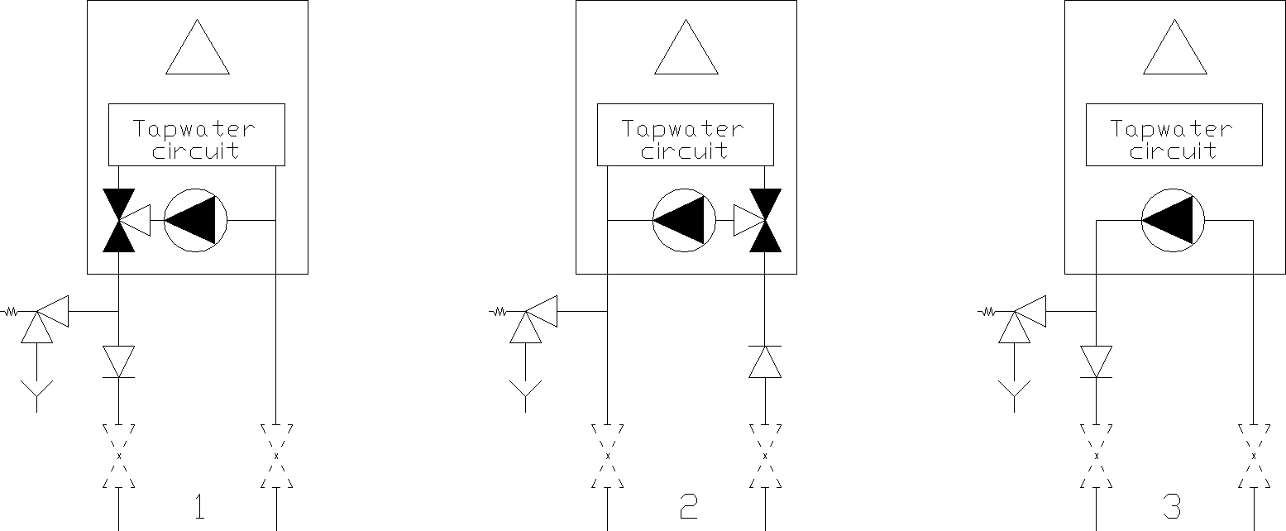

⚠ Please note! If it is not known in which position the tap water valve is at rest, this should be checked with the supplier or manufacturer of the central heating boiler.

**Figure 4-4 Position check valve, check for exceptions in Table 4.1**

##### Hydraulic connections in combination with an open distributor

In combination with district heating, the Elga is connected in series. The circulation pump of the Elga thus also becomes the transport pump of the delivery system. Check whether the pump is sufficiently strong for this. It is highly recommended to connect the district heating to an open distributor in the supply of the Elga see SV1 to SV7 in chapter [17.](#_bookmark50)  [Figure 4-5](#_bookmark10) shows how the open distributor should be connected to district heating (or specific central heating boilers).

##### Engine operated two-way valve when using district heating

**Figure 4-5**

If not already present, add an engine-operated two-way valve to the installation in the supply pipe of the district heating connection for central heating. This is necessary to shut off the district heating if the Elga does not need the district heating.

The Elga can open this valve with the on/off contact of the boiler. This can be with a maximum of 24 Volts. Various brands and types of valves can be found in the trade, which are supplied with a transformer. For example, the Honeywell Y-VC8015AG1100 (22 mm compression joints) or Honeywell Y-VC8015AJ1100 (3/4" BSP female thread) can be used.

⚠ **Please note!**  The contact in the Elga for controlling an on/off boiler is suitable for a maximum of 24 Volts.

# Installation outdoor unit

## Placement of the outdoor unit

##### To install and install the outdoor unit, follow the supplied manual for the Toshiba outdoor unit.

General points of attention are:

* + - Prevent noise or ventilation nuisance to the (immediate) environment.
    - Attach the outdoor unit with specialized materials for outdoor units (such as the Elga mounting sets).
    - If necessary, place the unit on specialized vibration dampers for outdoor units (not included).
    - Avoid placement on or on structures that can easily transport the sound further.
    - Pay attention to the prescribed space around the outdoor unit.
    - Prevent the outdoor unit from coming into contact with industrial or maritime atmospheres. Any damage resulting from this is not covered by the warranty. Techneco can lever the outdoor unit with protective coating.
    - The outdoor unit must be safe to reach for maintenance and/or replacement.
    - Always keep the device upright, even when installation.

⚠ **Please note!**  During heating operation, condensation water will run out of the outdoor unit.

## Electrical connection of the outdoor unit

The Toshiba outdoor unit is powered from the Elga indoor unit. Electrical connection between Elga indoor and outdoor unit is realized by a four-wire heater (not included).

|  |  |  |  |
| --- | --- | --- | --- |
| **Comm 3** | **Phase L** | **Zero N.** | **Earth PE** |
| Black | Brown | Blue | Green/yellow |

##### To do this, use a cable with hard cores of at least 4 x 1.5 mm2, which is suitable for outdoor application.

Remove the three screws from the plastic cover of the outdoor unit. Slide the cover down from the guide and then remove it.

Disassemble the strain relief and attach the four-wire feeding cable according to [Fi- guur 5-2.](#_bookmark11) Then reassemble the strain relief. Pull the power cable along the top of the indoor unit. Connect the four-wire cable coming from the outdoor unit to the green plug at the top left of the Elga indoor unit.

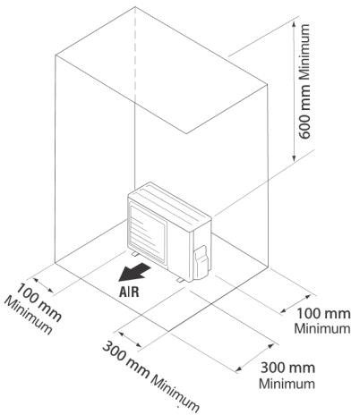

##### Figure 5-1

⚠ **Please note!**  that the connections correspond to the Coding on the outdoor unit, the order is different than in the indoor unit. See chapter [17](#_bookmark50) for

the complete electrical diagram.

**Figure 5-2**

⚠ **Please note!**  Connect the outdoor unit only if the Elga is voltage-free.

## Connecting the refrigerant side of the outdoor unit

These operations may only be carried out by an F-gas certified company.

The Toshiba outdoor unit is filled with 0.8 kg R410a. The minimum length of each of the two pipes is 2 meters and the maximum length is 15 meters with the standard filling and up to 20 meters if refrigerant is Topped. The maximum height difference between indoor and outdoor unit is 10 meters. The refrigerant pipes must be insulated vapour-tightly.

⚠ **Please note!**  The indoor unit is extorted with nitrogen (N2) at a pressure of 25 bar. After that, the indoor unit was put on pressure of approximately 2.5 bar.

⚠ **Please note!** For refrigerant pipes with a length between 15 meters and 20 metersRefill 20 grams of refrigerant for each metre Above 15 meters.

# Connection of boiler and thermostat

This chapter describes how to connect the thermostat and boiler to the Elga indoor unit.

* + - **Step 1:** Place the thermostat according to the supplied manual.
    - **Step 2:** Pull a two-wire weak current calyte from the thermostat to the Elga.
    - **Step 3:** Pull a two-wire weak current cable from the Elga to the boiler or district heating valve.
    - **Step 4:** Place the supplied tube clamp sensors NTC1 and NTC2 in the central return line and central supply line respectively. See chapter [17](#_bookmark50) for the exact locations.
    - **Step 5:** Connect the thermostat, boiler and temperature sensors to the green 13-pin plug on the bottom/inside of the Elga. See [Figure 6-1.](#_bookmark13)

⚠ **Please note!**  Use a low current cable of at least 2x0.14 mm2 and a maximum resistance of 2x5 Ω

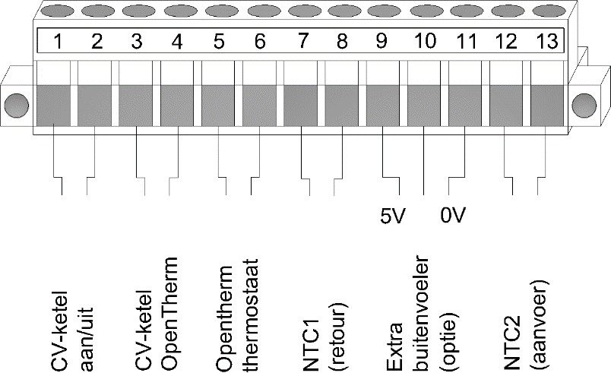

## Thermostat compatibility

##### Figure 6-1

The Elga heat pump comes standard with the Honeywell Chronotherm Touch Modulation (TH8210M1003) room thermostat. The supplied thermostat supports all functions that are important for the Elga. The Elga can also work with other thermostats, but these do not support all functions of the Elga.

In the design manual of the Elga you can find the current list of the tested thermostats (see [https://techneco.nl/documentatie-elga-hybrid heat pump/](https://techneco.nl/documentatie-elga-hybride-warmtepomp/)). Each function described in this list is further explained in this chapter.

If your thermostat is not listed and you are sure that it does or does not work, we would appreciate it if you inform Techneco of this.

##### Heat

For an optimal efficiency and comfortable climate, it is important to make a good trade-off between switching on the Elga heat pump and / or the central heating boiler. In order to be able to make this assessment properly, an OpenTherm room thermostat is necessary that, in addition to the mandatory OpenTherm values, also transmits at least the following values:

* + - * the desired room temperature
      * the measured room temperature

##### Automatic cooling

In order to operate the cooling function of the Elga via the thermostate, it must also support cooling functionality. If the thermostat does not support this, the cooling function on the Elga can be activated manually. For explanations, see chapters [10.4](#_bookmark37) and [10.5.](#_bookmark38)

##### Weather-dependent control

To control weather-dependent, an additional outdoor temperature sensor must be placed (from the sun and on the north façade) and Elga and the supplied thermostat must be configured correctly. See chapter [11.](#_bookmark40)

## Boiler compatibility

The Elga can be combined with any brand and type of gas boiler. The Elga can control the central heating boilers via the OpenTherm protocol or release them via an on/off contact. The rule is to use it if the boiler has an OpenTherm connection. If the boiler does not have an OpenTherm connection, it can be controlled by on /off. A number of exceptions apply to this.

Visit: [https://techneco.nl/do](https://techneco.nl/documentatie-elga-hybride-warmtepomp/) [cumentation-elga-hybrid heat pump/](https://techneco.nl/documentatie-elga-hybride-warmtepomp/) and select the Elga design manual.

If your boiler is not listed and you are sure that it can or cannot be connected to the Elga via OpenTherm, we would appreciate it very much if you inform Techneco of this.

# Interface

In this chapter the ministry of the Elga is described. The Elga can be read in three different ways. Firstly, a display is mounted on the front of the Elga indoor unit. Secondly, the supplied thermostat can be used and thirdly, the various LEDs can be read on the Elga circuit board.

## Display

A display is mounted on the front of the Elga indoor unit. This display shows two control buttons and five symbols, see [Figure 7-1.](#_bookmark17)  The table below explains the functions of the buttons and the meaning of the symbols.

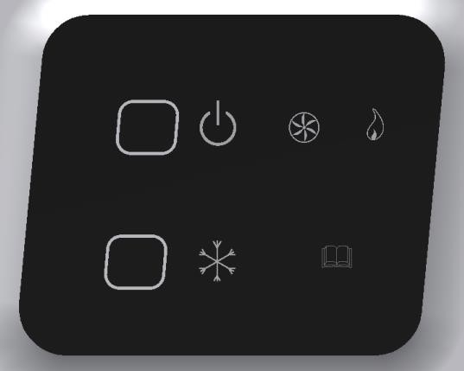

|  |  |  |
| --- | --- | --- |
| **Symbol** | **Function** | Button 1  Button 2  **Figure 7-1** |
|  | **Button 1: On/Off (red LED)**  LED on: the heat pump is switched on and will function together with the boiler for heating.  LED off: the heat pump is switched off. For heating, only the central heating boiler will be used.  LED flashing: Elga is externally blocked for heating. Or the scheme is starting up. |
|  | **Button 2: Release cooling (blue LED)**  LED on: the heat pump can be used for cooling. LED off: The heat pump cannot be used for cooling. LED flashing: Elga is externally blocked for cooling. |
|  | **Operating indication outdoor unit (green LED)**  LED on: the outdoor unit is in operation. LED off: the outdoor unit is in standby. |
|  | **Operating indication boiler (orange LED)**  LED on: the boiler is in operation. LED off: the boiler is in standby.  LED flashes: there is enough demand to use the boiler, but the boiler is off because, for example, the water temperature has reached the set point. See chapter [9.3](#_bookmark26) |
|  | **Interference (yellow LED)**  LED off: the Elga has no malfunction.  LED flashing: The Elga has a malfunction and is locked.  In case of malfunction, switch off the Elga with button 1. See chapter [12](#_bookmark47) for more information. |

## http://shop.cvkoopjes.nl/19884-large/honeywell-chronotherm-touch-modulation-klok-thermostaat.jpgThermostate

The standard supplied thermostat is the Honeywell Chronotherm Touch Modulation, shown in [Figure 7-2.](#_bookmark19)  For instruction on how to operate the thermostat, the manual that comes with the thermostat can be guessed.

##### Figure 7-2

**Changing installer settings**

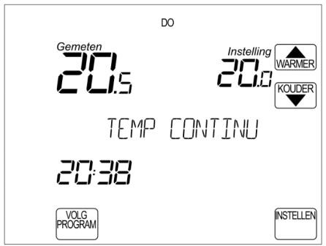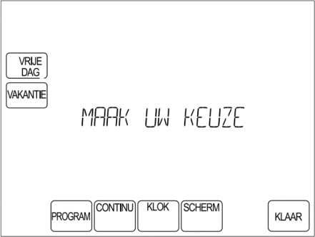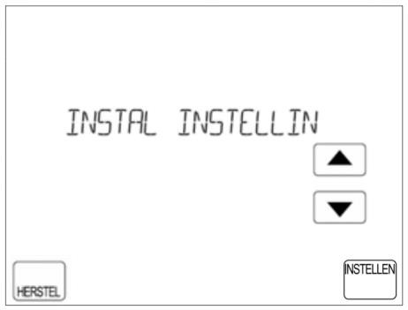

|  |  |  |
| --- | --- | --- |
| Step 1  Press **SET.** | Step 2  Keep the blank box between **SCREEN** and  **READY** for at least 5 seconds.  *5 seconds* | Step 3  Choose "INSTAL INSTELLIN" or the menu erbo- ven "INSTAL KETEL" (see chapter [19.1](#_bookmark52)).  Next menu "BOILER SETTING" |

## LEDs and DIP switches on Elga circuit board

[Figure 7-3](#_bookmark22) shows the Elga circuit board. The figure shows the meaning of the different LEDs present on the printed circuit board. With the help of these LEDs, the status of the heat pump can be easily determined.  [Figure 7-4](#_bookmark23) zooms in on the DIP switches and briefly describes the function of the different switches. The positions displayed on the DIP switches are the default factory settings.

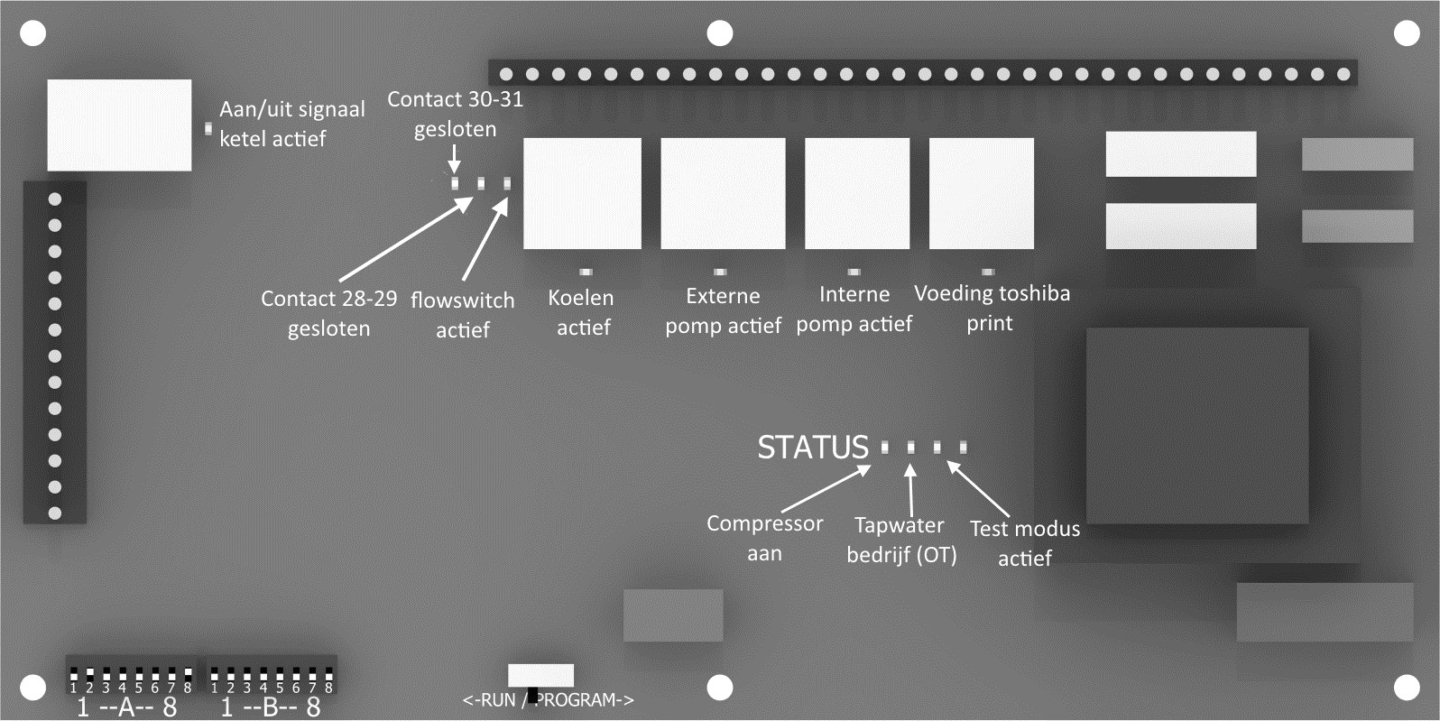

##### Figure 7-3

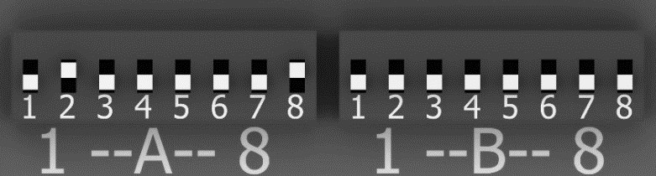

**Figure 7-4**

|  |  |  |
| --- | --- | --- |
| **DIP** | **OFF (to front print)** | **ON (to back print)** |
| A1. | Heating line low | Heating line high |
| A2. | Elga and central heating boiler not active at the same time | Elga and central heating boiler also active simultaneously |
| A3 | Radiator delivery system | Underfloor heating delivery system |
| A4 | Reduced desired room temperature ≤ 19°C Elga and central heating boiler can be used | Reduced desired room temperature ≤19°C only Elga usable |
| A5 | Sleep mode is turned off | Sleep mode is on |
| A6 | Thermostat supports cooling | Thermostat does not support cooling |
| A7 | N/a. | N/a. |
| A8 | Central heating boiler type OpenTherm control | Central heating boiler type on/off control |

|  |  |  |
| --- | --- | --- |
| **DIP** | **OFF (to front print)** | **ON (to back print)** |
| B1. | No extra outdoor sensor | External outdoor sensor applied |
| B2 | Weather-dependent control off | Weather-dependent control on |
| B3. | Parallel connection of the Elga | Serial connection of the Elga |
| B4. | N/a. | N/a. |
| B5. | N/a. | N/a. |
| B6. | If heating is blocked via an external contact, the central heating boiler will switch on immediately | If heating is blocked via an external contact, the central heating boiler will not switch on |
| B7. | External contacts 28 to 31 are blocking contacts | External contacts 28 to 31 are release contacts |
| B8. | Heat pump switches off below the set external temperature limit (standard 4°C) | Heat pump may remain on below the set external temperature limit |

**Explanation dipswitches**

|  |  |
| --- | --- |
| **DIP** | **Definition** |
| A1. | Choice of the low or high firing line for the installation; if the house does not reach temperature, the higher heating line can be chosen. See [Figure 10-2](#_bookmark39) for the firing lines. |
| A2. | Choice whether the Elga and boiler can run at the same time. If it is not possible to run the boiler and Elga at the same time, because this causes flow disturbances, the simultaneity can be switched off. |
| A3 | Choice of delivery system; if there is a combination of (high temperature) radiators and underfloor heating in the house, radiators must be chosen. |
| A4 | At a desired room temperature of 19°C or lower, you can choose to rotate the Elga alleen (showers>4°C). The 19°C can be changed with P70 (see chapter [19.2)](#_bookmark53) |
| A5 | If this feature is enabled, power to the Toshiba print will be turned off if there has been no heat or cold demand for a long time. By default, this period is 10 hours. When the Elga goes into sleep mode, the last measured outer temperature remains in the picture. The function reduces the standby consumption of the Elga. |
| A6 | This is a choice whether or not the thermostat can cool automatically. If the thermostat does not support cooling and A6 is set to ON, then the Elga will not see a heat demand as a cooling demand and the Elga will cool as long as the cooling on the front is indicated with button 2. The included Honeywell Touch Modulation supports cooling (see chapter 9.2), so A6 stands  default to OFF. |
| A7 | Must always be set to OFF. |
| A8 | Choice of whether the central heating boiler is controlled via OpenTherm or on/off. |

|  |  |
| --- | --- |
| **DIP** |  |
| B1. | Choose whether an extra outdoor sensor is used. We advise you to apply this if the Elga is used weather-dependent or if the outdoor unit is too much affected by the sun. |
| B2 | With OFF the Elga is thermostatically controlled (see chapter [10)](#_bookmark34) and with ON weather dependent (see chapter [11).](#_bookmark40) |
| B3. | Choice in parallel (OFF, diagrams K1 to K14) or serial (ON, for district heating, scheme SV1 to SV7). See the installation diagrams chapter [18.](#_bookmark51) |
| B4. | Must always be set to OFF. |
| B5. | Must always be set to OFF. |
| B6. | If the Elga is blocked externally, the boiler is also not controlled if the dip switch is set to ON. If the dip switch is set to OFF, the boiler will be controlled immediately in case of heat demand. |
| B7. | With this dip switch on ON, the external contacts become 28 to 31 release contacts (closing contact means release/question) instead of blocking contacts (closing contact means blockage/no question). |
| B8. | With the dip switch on ON, the Elga is no longer switched off below the set outside temperature limit (standaard 4°C). If the dip weight is set to OFF, the Elga below the outside temperature limit will only turn on the boiler. The external temperature limit of the heat pump can be lowered by means of parameter P62 the outside temperature per degree.  framed. For more information go to chapter [9.5.](#_bookmark29) |

# Commissioning

Before the commissioning of the Elga heat pump can be started, the installation must first be completed hydraulically, cold-technically and electrically. When commissioning, perform the following actions successively to ensure the proper functioning of the Elga. Commissioning is done using a Honeywell Chronotherm Touch Modulation thermostat. If the Elga is installed with a different thermostat, temporarily close a Honeywell Chronotherm Touch Modulation aan.

⚠ **Please note!**  Commissioning is carried out with a Honeywell Chronotherm Touch Modulation connected to the device.

* + - **Step 1:** Check all electrical connections
    - **Step 2:** Check the connections of the refrigerant pipes
    - **Step 3:** Check the connection to the central heating system
    - **Step 4:** Check the positions of the DIP switches according to the chosen installation scheme (see system selection chapter 3)
    - **Step 5** : Plug it in
    - **Step 6:** wait for the Elga to start up, this will take about 2 minutes. When the red LED of the on/off button is continuously lit, the Elga is started, see [Figure 8-1](#_bookmark25)
    - **Step 7:** Set the thermostat, see chapter [8.1](#_bookmark24) for explanation

## Thermostat setup

##### Figure 8-1

During commissioning, connect the Honeywell Chronotherm Touch Modulation directly to the Elga. The thermostat will first ask for the time and date when starting up. Set it up.

**Step 8:** Release the cooling function on the thermostat to prevent heating in the summer (even if the Elga is not allowed to cool)

* + - Press 'SET' on the screen
    - Press the blank piece between 'DONE' and 'SCREEN' for 5 seconds
    - Select with the tiles: 'INSTAL SETTING'
    - Then with 'SET' by going to the installer menu of the thermostat
    - Then set the following setup codes :

##### 0013 HEAT COOLING to 1

* + - Press 'DONE'

Then continue to Step 9 in Chapter 8.2 (Elga and boiler connected in parallel) or in Chapter 8.3 (Elga and district heating connected in series)

## Elga parallel hydraulic adjustment (K1 to K14)

**Step 9:** Testing the circulation pumps

* + - On the screen, press 'SET'.
    - Press the blank piece between 'DONE' and 'SCREEN' for 5 seconds .
    - Go with the arrow to "SET BOILER", this is the parameter menu of the Elga.
    - Press 'SET'.
    - Then set the following setup code:

##### P0085 on 1

* + - Press 'DONE'.

This enables test mode 1 – "Circulation pumps on". The internal circulation pump will start running.

* + - * Check that the ring around the red button on the circulation pump turns green .
      * Then check if the flowswitch LED lights up. For the position of the flowswitch LED see [Figure 7-3.](#_bookmark22)  If necessary, vent the installation. This can be done by means of the vent valve just above the circulation pump in the Elga. If the flowswitch LED does not light up, there is a flow failure.
      * Adjusting circulation pump (without boiler):
        + In the delivery system, make sure that the minimum number of requesting groups is open.
        + Set the circulation pump to position 2 (minimum position). If a flow failure occurs, pump adjustment can be increased with small steps until the flow failure does not occur.

If there is still a flow failure, see chapter [12](#_bookmark47) (6th flash long) for possible causes and solutions.

**Step 10:** testing the heat pump (outdoor unit)

* On the screen, press 'INSTELLEN'.
* Press the blank piece between 'DONE' and 'SCREEN' for 5 seconds .
* Go with the pijtje to "SET BOILER", this is the parameter menu of the Elga.
* Press 'SET'.
* Then set the following setup code :

##### P0085 on 2

* Press 'DONE'.

This enables test mode 2 – "Heat pump on". The Elga will now control the outdoor unit for heating.

• Check that the outdoor unit starts up and the "Compressor on" LED lights up. For the position of this LED see [Figure 7-3.](#_bookmark22)

• Check parameter P23. This becomes 1 when the outdoor unit is running.

• Then check the measured supply temperature **P4** and return temperature **P5**. The temperature difference between P4 and P5 is about 3 degrees.

• If necessary, check the current consumption of the outdoor unit. This is 3.5-5 Amps at full load. On the thermostat it can be read as a percentage via the Installer Menu 0021 Current power.

**Step 11:** testing the heat pump and central heating boiler

* On the screen, press 'SET'.
* Press the blank piece between 'DONE' and 'SCREEN' for 5 seconds .
* Go with the pijtje to "SET BOILER", this is the parameter menu of the Elga.
* Press 'SET'.
* Then set the following setup code:

##### P0085 on 3

* + Press 'DONE'.

This enables test mode 3 – "Heat pump + central heating boiler on". Both the Elga and the central heating boiler are controlled for heating. An OpenTherm central heating boiler is controlled with a setpoint of 50°C. An on/off central heating boiler will be switched on.

If a central heating boiler is used, check whether both the central heating boiler and the heat pump will run. Check whether there is sufficient flow in the Elga (LED flow switch is on), and check whether there is sufficient flow through the central heating boiler. Using the steps below, adjust both circulators so that both devices can run simultaneously and the system flow rate is distributed among the devices.

* + If the boiler gets a flow failure (or similar), increase the minimal position of the boiler's circulation pump from, for example, 30% to 40-50%.
  + If the Elga gets a flow failure, lower the maximum position of the boiler's circulation pump from, for example, 90% to 70%.
  + If the Elga continues to give flow failure, increase the position of the circulation pump of the Elga slightly.
  + If, after the necessary adjustment work, one of the two failures continues to occur, then parallel operation is not possible due to a too high weather position in the delivery system. Then we advise not to run the boiler and the Elga simultaneously by setting dip switch A2 to OFF .

⚠ **Please note!**  See recommended settings for the central heating boiler chapter [9.3.1.](#_bookmark27)

**Step 12:** switch the heat pump to normal operation

* On the screen, press 'SET'.
* Press the blank piece between 'DONE' and 'SCREEN' for 5 seconds .
* Go with the pijtje to "SET BOILER", this is the parameter menu of the Elga.
* Press 'SET'.
* Then set the following setup code :

##### P0085 on 0

* + Press 'DONE'.

The heat pump is now in normal operation.

## Elga and open distributor serial hydraulic adjustment (SV1 to SV7 and K15)

For district heating and for specific boilers, we advise to connect the Elga serially. When adjusting, follow the steps below.

**Step 9:** testing the circulation pumps

* + - On the screen, press 'SET'.
    - Press the blank piece between 'DONE' and 'SCREEN' for 5 seconds .
    - Go with the arrow to "SET BOILER", this is the parameter menu of the Elga.
    - Press 'SET'.
    - Then set the following setup code :

##### P0085 on 1

* + - Press 'DONE'.

This enables test mode 1 – "Circulation pumps on". The internal circulation pump will start running.

* + - * Check if the red button on the circulation pump lights up.
      * Then check if the flowswitch LED lights up. For the position of the flowswitch LED see [Figure 7-3.](#_bookmark22)  If necessary, vent the installation now. This can be done by means of the vent valve just above the circulation pump in the Elga. If the flows-witch LED does not light up, then there is a flow failure.
      * Adjusting circulation pump (without boiler/district heating);
        + In the delivery system, make sure that the minimum number of groups is open
        + Set the circulation pump to position 2 (minimum position). If a flow failure occurs, pump adjustment can be increased with small steps until the flow failure no longer occurs.

If there is still a flow failure, see chapter [12](#_bookmark47)  for possible causes and solutions. (6th flash long).

**Step 10:** testing the heat pump (outdoor sensor)

* + - On the screen, press 'SET'.
    - Press the blank piece between 'DONE' and 'SCREEN' for 5 seconds .
    - Go with the pijtje to "SET BOILER", this is the parameter menu of the Elga.
    - Press 'SET'.
    - Then set the following setup code :

##### P0085 on 2

* + - * Press 'DONE'.

This enables test mode 2 – "Heat pump on". The Elga will now control the outdoor unit for heating.

* + - * Check that the outdoor unit starts up and the "Compressor on" LED lights up. For the position of this LED see [Figure 7-3.](#_bookmark22)
      * Check parameter P23. This becomes 1 when the outdoor unit is running.
      * Then check the measured supply temperature **P4** and return temperature **P5**. The temperature difference between P4 and P5 is 3-5 degrees.
      * If necessary, check the current consumption of the outdoor unit. This is 3.5-5 Amps at full load. On the thermostat it can be read as a percentage via the Installer Menu 0021 Current power.

See following page for step 11.

**Step 11:** testing the heat pump and central heating boiler or district heating.

* On the screen, press 'SET'.
* Press the blank piece between 'DONE' and 'SCREEN' for 5 seconds .
* Go with the pijtje to "SET BOILER", this is the parameter menu of the Elga.
* Press 'SET'.
* Then set the following setup code :

##### P0085 on 3

* + Press 'DONE'.

This enables test mode 3 – "Heat pump + central heating boiler / district heating on". Both the Elga and the central heating boiler / district heating are controlled for heating. An OpenTherm central heating boiler is controlled with a setpoint of 50°C. An on/off central heating boiler or district heating will be switched on.

* + If district heating is used, check whether both the engine-operated two-way valve and the heat pump are switched on.
  + Check the flow ratio from the district heating to the delivery system. This can be done, among other things, by checking the incoming and outgoing temperatures on the open distributor. The ratios are equal is the temperature coming from the Elga is equal to the return temperature to the district heating and if the supply temperature to the delivery system is equal to the supply temperature from the district heating.
  + If the return to the district heating quickly becomes much warmer than the temperature from the Elga, then either the volume flow of the district heating must be reduced, or the volume current over the delivery system / the Elga must be increased. Do the latter only with small steps and afterwards also check the operating condition again with only the Elga and whether it is still fully revving.
  + If the supply temperature to the delivery system remains (far) behind the temperature of the supply temperature from the city heating, increase the volume flow of the district heating or reduce the volume flow of the delivery system/Elga. With the latter action, check whether the Elga keeps sufficient volume current and no flow disturbances occur.
  + A mixing temperature in the central supply temperature ensures that the Elga shuts off the district heating less quickly. This may be desirable to get enough heat into the system. However, it can also be an undesirable effect if the Elga can be less on or the average temperature in the delivery system is too low when it is cold outside.
  + Perform the same check again at full load (all groups open) and make sure that the deviations in temperature are not too large (<5 K). If necessary, allow a little more volume flow on the district heating side. Installations that are equipped with a return limiter will also regulate themselves and a slightly too high volume flow over the urban artery side is not bad, unless it is settled on volume (and not on temperature difference / energy).

# General regulation

The arrangement of the Elga can be divided into three parts. The overarching arrangement; it is described in this chapter. A choice must also be made between controlling the Elga thermostatically (see chapter [0](#_bookmark33)) or weather dependence (see chapter [11](#_bookmark40)). If a zone adjustment is applied, the Elga must be set again-dependent.

## Introduction scheme

The control of the Elga has been developed to initially control based on indoor temperature. For this purpose, a special control has been developed that requires both the set and the measured indoor temperature. The supplied room thermostat delivers it to the Elga via the OpenTherm protocol. The Honeywell thermostat is also suitable for automatic cooling and for the option of weather dependent control (see next chapter). The starting point for the control is to obtain an optimal combination between energy-efficient heating and the maintenance of comfort. For this purpose, the control uses the measured indoor temperature and, for example, a heating line to properly control the boiler.

## Description of control strategy

The heat pump has a maximum return temperature of 45°C and a maximum power of approximately 5 kW. This means that in most homes with radiators the heating of the house is done with the help of the central heating boiler or district heating. After that, the Elga will use the heat pump as much as possible to keep the house at temperature.

In order to use the Elga as economically as possible, the heat pump switches off as standard at outside temperatures lower than 4°C. The heat pump switches back on when the temperature is 6°C or higher, the return water temperature is low enough and the heat demand has been gone (the central heating boiler or district heating first brought the room up to temperature). The boiler or district heating and heating line in the Elga must therefore be set high enough to get the house up to temperature.

## Control central heating boiler/district heating

The Elga can control central heating boilers via both on/off and OpenTherm. If the Elga can control the boiler via OpenTherm, the control works more accurately and there is less chance that the central heating boiler will 'push away' the Elga. The Elga can also receive a fout notification from the boiler via OpenTherm, for example.

##### CV boiler OpenTherm

If, according to the Elga regulation, the central heating boiler must be heated, a desired supply temperature for central heating boiler is calculated. The heating line set with the dip switches A1 and A3 determines the desired supply temperature. Even if only the boiler is running, the desired supply temperature for the central heating boiler depends on the set heating line.

The boiler also sends a signal to the Elga when it has reached its set point. If the central heating boiler goes out because the desired water setpoint has been reached, but there is still sufficient heat demand on the Elga to use the boiler, the Elga will use the flame symbol on the flash the front of the Elga. If the boiler makes tap water, the Elga will receive this signal and show it on the thermostat. Even then, the flame symbol flashes on the front of the Elga.

It is also possible that the flame symbol flashes because the CV chain remains off during the overrun time of the Elga circulation pump. This therefore occurs when switching from Elga to central heating boiler.

##### Central heating boiler/district heating on/off

If the central heating boiler (or district heating) is controlled via the on/off contact, the boiler or district heating will make/deliver its own supply temperature. The central heating boiler/district heating valve is switched on when the measured supply temperature (NTC2) is lower than: *Desired supply temperature central heating boiler – 10K*.

The central heating boiler/district heating will be switched off again by the Elga if the measured supply temperature (NTC2) is higher than the desired supply temperature. If the Elga turns off the central heating boiler or district heating because the desired supply water temperature is exceeded, but there is still sufficient heat demand to release the boiler or district heating, the flame symbol on the front of the Elga will flash.

It is also possible that the flame symbol flashes because the central heating boiler remains off during the overrun time of the Elga circulation pump. Dit therefore occurs when switching from Elga to central heating boiler.

##### Tap water

The Elga is not used for tap water preparation. The preparation of tap water is done by the central heating boiler and is not controlled by the Elga scheme. If the central heating boiler indicates via OpenTherm that it is in tap water operation, the Elga will pass this on to the thermostat and the flame symbol will flash on the front of the Elga.

##### Control/settings of the boiler

For various boilers, settings are possible that can cause problems if they have to work in combination with the Elga. Below is a list of points of attention and boilers where this certainly applies. Please note, the list may not be complete (not all situations and boilers are known to us). If you come across a new brand or type that experiences a similar malfunction, we would like to hear from you.

Furthermore, make sure that the central heating boiler is adjusted as well as possible for the maximum power and supply temperature to be delivered for the central heating system. In addition, adjust the circulation pump well to simultaneous operation with the Elga.

⚠ **Please note!** If the central heating boiler has a frost protection That ensures That the internal circulation pump is continuously controlled, switch off this function.

Some central heating boilers have included frost protection in their control system that continuously controls the internal circulation pump. Check the parameter list and settings of the central heating boiler and disable this function. If the ketel is not set properly, for example, the boiler can heat directly instead of the Elga or malfunctions can occur.

## Refrigeration company

For the use of the cooling function of the Elga, the delivery system must be suitable. If the thermostat requires cooling, the Elga will control with the outdoor unit to a desired supply temperature for cooling. This supply temperature is determined by .m of a cooling line shown in [Figure 9-1.](#_bookmark28)  The standard cooling line is suitable for floor cooling. The minimum exit temperature for cooling is 5°C. If this is achieved, the outdoor unit will be switched off until the measured exit temperature exceeds 10°C.

Cooling in the Elga can be used in three different ways. First, thermostatically with a thermostat that supports automatic cooling (see chapter [6).](#_bookmark12) Secondly, with a thermostat which is not suitable for cooling (see chapter [10.5](#_bookmark38)). The third option is the Elga cools in weather-dependent operation (see chapter [11.4).](#_bookmark42) The cooling line in [Figure 9-1](#_bookmark28) is the same in the three situations.

The cooling line from the supply temperature in [Figure 9-1](#_bookmark28) state standard set. This is too change with P73 (minimum supply temperature 15°C) and P74 in parameter menu described in chapter [19.2.](#_bookmark53) The hysteresis of cooling is here can also be adjusted with the para-meters P71 and P72.

**Desired supply temperature during cooling**

22

21

20

19

18

17

16

15

Cooling line

21222324252627282930

Outside temperature [°C]

Supply temperature [°C]

##### Figure 9-1

## Outside temperature below outside temperature limit heat pump

If the measured outside temperature is lower than the outside temperature limit for the heat pump (standard 4°C), the Elga control will only control the central heating boiler/district heating for heating. The desired supply temperature is then calculated according to the heating line set with the dip switches A1 and A3. The outside temperature limit of 4°C can be adjusted via parameter P62 in the Honeywell thermo-state. The complete elimination of this limitation is possible with the help of dipswitch B8, see chapter [7.3.](#_bookmark21)

## After running times and pump circuits

After cooling or defrosting, the circulation pump of the Elga has a trailing time of 5 minutes. During heating operation, that's 30 seconds. If the circulators are not controlled for 24 hours, they will be controlled for 30 seconds to prevent them from getting stuck. This also applies to any additionally connected circulation pump on the pump contact of the Elga.

## External outdoor sensor

In some homes, the outdoor unit is in the sun. If the fan of the outdoor unit is not running, then no good outside temperature can be measured. Because the supply temperature of the central heating boiler is also determined on the basis of the outside temperature, a good outside temperature is required. For this, an additional outdoor sensor can be connected with a three-wire cable. The outdoor sensor is available from Techneco (TRB, article number 60069).

After placing the outdoor sensor, it must be activated with dipswitch B1. With an external outdoor sensor, the outdoor sensor of the outdoor unit is only used to switch off the heat pump below 4°C.

## Extra contacts (cable for extra functionality)

A number of additional contacts are available on the Elga circuit board (see Table 9.1). For connecting the contacts 19 to 33 is a separate kabell/plug available from Techneco (article number 60509). The cable must be connected as indicated in [Figure](#_bookmark32) [9-2](#_bookmark32) with the circled plugs in the drawing.

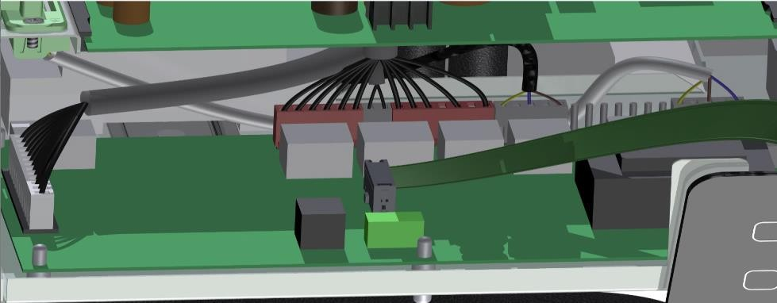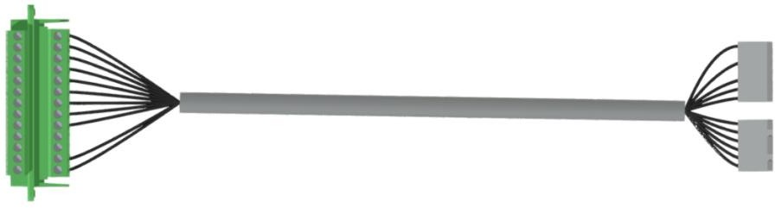

Figure 9-2

Attach to the bottom of the Elga

|  |  |  |
| --- | --- | --- |
| **#** |  |  |
| 19 | Common | External pump contact Potential-free,  external power supply, max. 230V AC, 2A |
| 20 |  |
| 21 | NO |
| 22 |  |
| 23 | NO | Summer/Winter contact Potential-free,  Max. 24V.1A |
| 24 | Common |
| 25 | NC |
| 26 |  | Not plugged in; Flow switch |
| 27 |  |
| 28 | + | Release/block Cooling |
| 29 | - |
| 30 | + | Release/blockage Heating |
| 31 | - |
| 32 | + | Fault contact |
| 33 | - |

Table 9-1

⚠ **Please note!**  Contacts 23 to 33 are only suitable for low current.

⚠ **Please note!** The numbering above is from the connections on the plug and pins of the PCB. The above numbering does not match the numbers behind the letters JB on the circuit board. Other versions of the print have instead of the JB numbering

text next to the Pins.

### Fault contact (32 and 33)

A fault contact is present on the circuit board (see [Table 9-1).](#_bookmark31) If the Elga is in trouble (i.e. the fault light flashes) this contact will be switched so that the status can be read externally. This is a potential-free contact.

### Summer/winter contact (23 to 25)

There is a summer/winter contact on the circuit board (see [Table 9-1)](#_bookmark31) that switches when the Elga switches operating mode. This allows the Elga to let the outside world know whether it is heating or cooling. This can be used, for example, to make an after-regulation work properly.

### Locking or release heating and cooling (28 to 31)

With the two buttons on the front, the heat pump can be put into operation and cooling can be released. These functions can also be blocked externally (see [Table 9-1).](#_bookmark31) If the functions are blocked externally, but released on the control panel, the status LEDs will flash instead of being solidly lit. With dipswitch B7, the contacts can be set as blocking contacts (closing is blocking) or release contacts (closing is release).

### External pump (19 and 21)

In some installations, a circulation pump for underfloor heating is connected by the central heating boiler or thermostat. When installing an Elga, the problem occurs that the underfloor heating pump does not run if only the heat pump heats.

The potential-free contact for an external pump on the Elga PCB (230 VAC, max. 2 A) is switched if there is heat or cold demand. This contact is also switched in cooling operation. The contact has the same overrun times and anti-blockage function as the internal circulation pump (see [Table 9-1](#_bookmark31)).

# Thermostatic control

The Elga regulates based on the measured and desired temperature in the reference room. Because the indoor temperature is used to control the Elga and central heating boiler / district heating, the thermostat must be hung in a good position in a reference room.

## The room thermostat

The Honeywell Chronotherm Touch Modulation room thermostat is supplied as standard with the Elga (see [Figure 10-1](#_bookmark36)).

The Elga control requires the following data from the room thermostat to function:

* + - representative measured room temperature

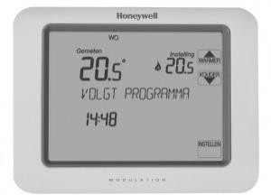

**Figure 10-1**

* + - desired room temperature
    - whether or not a heating question
    - whether or not cooling demand

The Elga regulation will decide on the basis of the following data whether the heat pump, the central heating boiler / district heating or both should heat the house:

* + - the difference between measured and desired room temperature
    - the time and extent to which the measured indoor temperature is below the desired room temperature (degree minutes control)
    - the outside temperature, measured by the outdoor unit

Chapter [10.2](#_bookmark35) explains in detail when the boiler/district heating is controlled.

## Switching on central heating boiler or district heating

In addition to the outside temperature limit for the heat pump, other switch-on conditions apply for the central heating boiler or district heating.

* + - If the water temperature is too high (return > 45°C), the heat pump will switch off and the central heating boiler/district heating will completely take over the confusion. This remains the case until the desired room temperature is reached. If heat demand arises again, the Elga will be the first to switch on the heat pump if the water temperature is low enough (return < 45°C).
    - In the Elga there is a degree minute regulation. This starts counting when the room temperature falls below the set value. The control switches on the boiler or district heating when the limit is reached. This can be after a very long time because there is only a very small deviation or after a shorter time because the deviation is larger.
    - If there is more than 1°C difference between the measured and desired indoor temperature, the control also switches on the boiler/city heating.
    - The central heating boiler that is controlled on/off or the district heating goes out if the supply water temperature is higher than the heating line set with the dip switches A1 and A3. It is therefore important to properly regulate the central heating boiler or district heating , to set it (power / temperature limit in boiler) and to test this when commissioning.
    - If the outdoor unit of the Elga is in the sun , a wrong outside temperature can be measured, so that the central heating boiler or district heating is too low bounded by the heating line of the Elga. Choose a place from the sun for the outdoor unit or use an extra outdoor sensor.

## Reduced desired room temperature

If the function "lowered desired room temperature" (dipswitch A4) is activated on the Elga, the control will recognize a desired room temperature lower than 19°C, but higher than 10°C, as "reduced temperature". The Elga will then only use the heat pump to maintain this temperature in the house; the boiler is blocked for space heating provided that the outside temperature remains above the outside temperature limit of the heat pump.

The usefulness of applying night reduction is very dependent on the insulation value and type of delivery system of the house. In well-insulated homes with underfloor heating, it is generally advisable to apply little or no night reduction. For homes with normal or poor insulation and radiators, the application of night reduction is advisable.

## Thermostat with automatic cooling

When the cooling function of the Elga is available, the Elga can deliver cold. This requires a cooling-capable delivery system, for example underfloor heating. Make sure that any circulation pump in the underfloor heating distributor is also active in cooling operation.

In order to switch on the cooling, a number of conditions must be met for thermostatic control.

1. In the thermostat, the cooling function is released. See chapter [8.1.](#_bookmark24)
2. The thermostat has a desired room temperature for cooling set that is lower than the measured temperature. Please note, there is a minimum bandwidth between the desired room temperature for cooling and heating.
3. Button 2 on the front of the Elga must be released; the blazing LED is lit. See [Figure 7-1.](#_bookmark17)
4. Dipswitch A6 is set as 'thermostat suitable for cooling' (OFF).

If the thermostat is not suitable for cooling but cooling is desired, see chapter [10.5.](#_bookmark38)

## Thermostat without cooling support

It is also possible to cool with the Elga if the thermostat is not suitable for cooling (the design manual contains a comptabilitation list). In order to switch the cooling, a number of conditions must be met when thermostatically controlled.

1. Button 2 on the front of the Elga must be released; the blue LED is lit. See [Figure 7-1.](#_bookmark17)
2. Dipswitch A6 is set as 'thermostat not suitable for cooling' (ON).
3. There is no heat demand from the thermostat.

The Elga will cool as long as there is no heat demand. If there is a heat demand on the thermal state, the cooling goes out. However, the Elga only heats up again when the cooling function is turned off with button 2 on the front of the Elga, see chapter [7.1.](#_bookmark16)

## Heating lines/heating control behaviour

In [Figure 10-2](#_bookmark39) stand the heating lines before the control/limitation from the Central heating boiler/district heating displayed. This heating lines be can be chosen by means of the dip switches **A1** and A3. In chapter [7.3](#_bookmark21) this is further explained. This firing line is intended solely as a boundary from the Central heating boiler/district heating; it is no control value before the Elga. The Elga Regulates on basis from the Measured and set indoor temperature. If the indoor temperature Drops Touring the Elga on if the indoor temperature the Desired temperature approaches tours down the Elga.

**Maximum supply temperature central heating boiler (limit)**

95

90

85

80

75

70

65

60

55

50

45

40

35

30

25

20

Radiators high (A3 off A1 on)

Radiators low (A3 off A1 off)

Underfloor heating high (A3 on A1 on)

Underfloor heating low (A3 on A1 off)

Outside temperature [°C]



##### Figure 10-2

Supply temperature [°C]

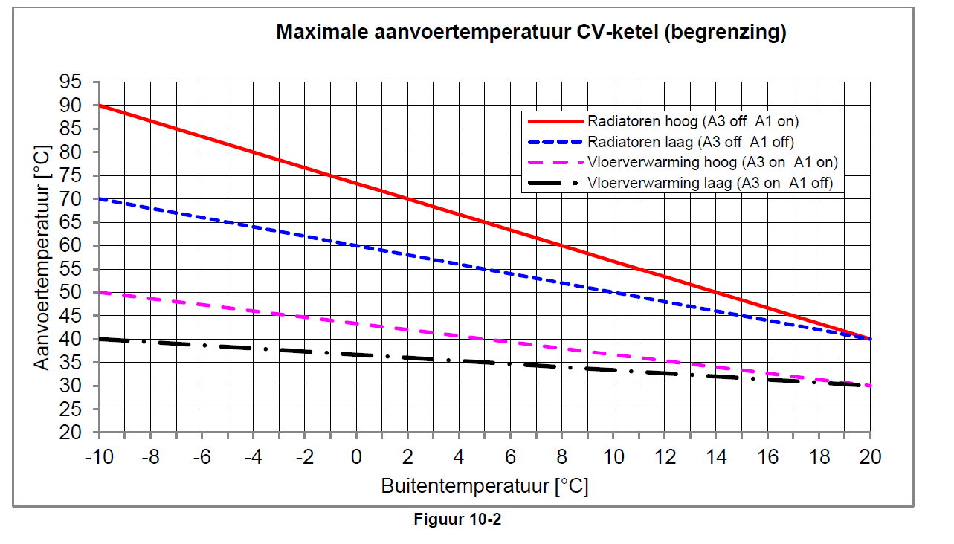

# Weather-dependent control

It is not always desirable to work with a thermostat. This is especially common if several reference rooms are needed, for example an office that needs to be heated separately from the living room during the day. In this situation , a weather-dependent control can be used.

By setting both the Elga and thermostat to weather-dependent control, the Elga uses the measured outside temperature to determine the desired water temperature.b based on the heating line set in the thermostat [(Figure 11-1](#_bookmark44)).

The Honeywell room thermostat supplied as standard serves as an interface and delivers the set heating line to the Elga via OpenTherm. Set the firing line that matches the delivery system. The Elga-regeling provides the thermostat with the outdoor temperature via the OpenTherm protocol. The thermostat sends a desired supply temperature (based on outside temperature) to the Elga control.

|  |  |
| --- | --- |
| **Advantage** | No reference room (location where thermostat hangs) is needed to determine the heating demand. Depending on the outside temperature, a water temperature is made. Theoretically, this should keep all rooms at the desired temperature. In practice, a post-regulation must be applied, because internal heat load cannot be predicted and this could lead to a too high or low indoor temperature. |
| **Disadvantage** | With a wrong firing line setting (on the Honeywell Touch), the room temperature can fall below or above the desired temperature.  If the post-control is not linked to the Elga, continuous 'heating' is carried out to keep the water at temperature. Cooling can no longer be controlled from the thermostat. If refrigeration is to be carried out, follow the instructions in section [11.4.](#_bookmark42) |

## Adjustments to the installation for use with weather-dependent control

An installation where a weather-dependent control is applied is different from a regular installation. The main differences are described below.

* + - Place a TRB outdoor sensor (article number 60069) on the north façade from the sun and connect it with a three-wire cable to the green plug at the bottom of the Elga. For selection of the relevant wiring diagram, see Chapter [6.](#_bookmark12)
    - Connect the Honeywell Chronotherm Touch Modulation to the Elga. The thermostatic function is not used so the ther- mustate does not have to hang in the reference room. Set your thermostat as weather dependent.
    - Install a spring-loaded bypass and a buffer tank of at least 25 litres if a zone control is used that can close all groups and/or radiators.

## Switching on central heating boiler or district heating

In the weather-dependent control, Elga/boiler is controlled on the basis of the average water temperature, the outside temperature, the stook line from the thermostat and the dip switches A1 and A3. This is further explained in [chapters 11.3](#_bookmark41) to [11.6](#_bookmark43).

## Heating control

The regulation of the Elga must be set for weather-dependent control. To do this, use the DIP switches B1 and B2 on the Elga circuit board.

|  |  |  |
| --- | --- | --- |
| **DIP** | **Function** | **Position in weather-dependent control** |
| B1. | External outdoor sensor | UN |
| B2 | Weather-dependent control | UN |

In addition, it is possible to influence the speed of response of the Elga and the switching on of the central heating boiler / district heating. The positions of dipswitch A1 and A3 determine the degree minutes for switching the Elga on and off and central heating boiler /city heating. In the first instance, choose the position of the dip switches in such a way that they fit the delivery system (as with thermostatic control). The lower the setting, the smaller the number of degree minutes for both switching the Elga and central heating boiler/district heating on and off.

|  |  |
| --- | --- |
| **DIP** | **Definition** |
| A1. | Choice of the low or high firing line for the installation; |
| A3 | Choice of delivery system; if there is a combination of (high temperature) radiators and underfloor heating in the house, radiators must be chosen. |

Dipswitches B6 and B7 may also need to be adjusted as post-regulation applicable is. See section 11.4.

The Elga regulates based on the average water temperature (between supply and return) and a degree minute control. There is a degree setting for switching the heat pump on and off and for switching the central heating boiler /city heating. If the average water temperature is too low, heating with the heat pump is immediately started if the other conditions (outdoor temperature and absolute water temperature) also allow this. When switching on the central heating boiler or district heating, we wait until the degree-minute limit is reached.

## Koelen

The Honeywell Touch Modulation thermostat does not support cooling if it is weather-dependent. In order to cool in the summer, the Elga must be set up differently.

|  |  |  |
| --- | --- | --- |
| **DIP** | **Function** | **Position in weather-dependent control** |
| A6 | Thermostat does not support cooling | UN |

Cooling can now be activated using the Button 2 on the control module (see section [7.1)](#_bookmark16) The Elga will now cool if it is warm enough outside and there is no heat demand from the thermostat. Cooling is done on the basis of the cooling line in Figure 9.1.

## Weather dependent + zone control/post-regulation

For combining a zone control such as the Honeywell EvoHome, Honeywell HCE20 or Danfoss CF2+, the weather-dependent control of the Elga is also used. The Elga is configured as weather-dependent and will be based on try to make the measured outside temperature a water temperature together with the central heating boiler / district heating.

The Elga control can be released by the on/off contact of the zone control via the extra cable (see chapter [9.8](#_bookmark30)). The Honeywell HCE20 is an exception to this. This controls the Elga directly via OpenTherm and is therefore connected to terminals 5 and 6 of the green plug.

⚠ **Please note!**  The Honeywell Chronotherm Touch Modulation must be connected to contact 5 and 6 of the Elga and set weather-dependent.

## Setting up Honeywell Touch thermostat

The thermostat will have to be adjusted differently in the event of weather-dependent control. Three settings must be changed in the installer menu. See chapter [7.2](#_bookmark18) to enter the installers menu. [Changing installer settings](#_bookmark20) about reaching the installer menu in the Honeywell Chronoterm Touch Modulation.

* + - In the installer menu, set parameter 29 (WEATHER AREA) to 1. After this, the thermostat will control weather-dependent.
    - Set the set/desired temperature to 22°C or higher to ensure that heat demand continues to come out of the thermostat even at higher outside temperatures (up to approximately 16°C outside ).

[•](#_bookmark46)

* + - [Figure 11-2](#_bookmark46) shows how much influence the set/desired temperature has on the desired supply temperature. With the selection of the heating line, take this shift into account.
    - In the installer menu, set parameter 30 (HEATING LINE INST). Choose this firing line in such a way that it fits the required temperatures of the delivery system. In this way, there can be continuous flow and sufficient power is delivered to keep the building at the desired temperature. See [Figure 11-1](#_bookmark44) for the different heating lines in the thermostat.

|  |  |
| --- | --- |
| **Figure 11-1 Heating lines at a desired room temperature of 20°C** | **Figure 11-2 Firing line shift of firing line 16 at desired room temperatures 15°C/20°C/25°C** |

# Fault reports

If the Elga detects a malfunction, this fault indication is indicated by means of the flashing yellow  LED. This LED flashes nine times, followed by a rest period. One or more flashes are, depending on the malfunction that has occurred, long and then give an indication of the malfunction. See Chapter 12.3 for the fault indications.

If there is a malfunction, the Honeywell Chronotherm Touch Modulation will also display a malfunction. In the image it says: "Boiler failure" by pressing *Info* you can see the fault code. If several faults are active at the same time, the codes are added together. For example: Interference NTC1 and NTC2 both active is code 8+4=12.

## Outside temperature remains 0°C on thermostat

If the Elga does not indicate a fault code, if the measured outside temperature by the outdoor unit is always 0°C, then there is a communication failure between the indoor and outdoor unit. Possible causes:

* + - the 4-wire cable between Elga indoor and outdoor unit has a break or
    - phase and zero between the indoor and outdoor unit are twisted.

## Fault notification of the circulation pump

If a malfunction occurs in the circulation pump, it is displayed on the circulation pump itself. It does this by blinking or changing color. Below are the different combinations with meaning and possible solution.

##### Table 12-1

|  |  |  |  |
| --- | --- | --- | --- |
| **LED color** | **Meaning** | **Cause** | **Solution** |
| Green | Pump runs normally |  |  |
| Green clipping-rend | Venting routine active | Pump runs for 10 minutes in venting routine. After this, the pump must be set to the desired working point |  |
| Red/Green | Abnormal situation. Pump works, but is in security mode | Wrong voltage Overheating | Check the power supply  Check the water and ambient temperature |
| Red clipping- running | Pump has stopped | Pump cannot restart itself due to continuous failure | Replace the pump |
| No LED | No power supply | The Elga control has not switched on the pump.  LED is damaged Electronics is damaged | Check the power cable Check if the pump is running Replace the pump |

The LED can be seen on the circulation pump around the red button. [**Figure 12-1**](#_bookmark48) shows this.

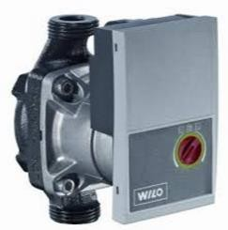

##### Figure 12-1

## Fault codes Elga

|  |  |  |
| --- | --- | --- |
| **Disruption on Elga** | **Code thermo-condition** | **Definition** |
| **1st flash long** | 1 | **Central heating boiler error message**  The boiler informs the Elga via OpenTherm that the central heating boiler has an error message. If the central heating boiler transmits a collision code via OpenTherm, it can be read out under parameter **P87**.  Remedy: solve the malfunction and reset the central heating boiler. Possible malfunctions can be: too low water pressure, too high temperature (flow boiler), no gas pressure, etc. Furthermore, reference is made to the manual of the central heating boiler. |
| **2nd flash long** | 2 | **Communication problem with the OpenTherm central heating boiler**  Check that the cable between the OpenTherm boiler and the Elga pcb is properly connected.  It is possible that the choice between on/off or OpenTherm is incorrectly connected to the connection crown of the boiler. It is also possible that an entry in the menu of the boiler is changed to OT. Consult the manual of the central heating boiler for this. Check whether the central heating boiler has an OpenTherm connection.  It is possible that the OpenTherm implementation of the central heating boiler is not compatible with that of the Elga. In this case, the central heating boiler can be controlled via an on/off contact. See schedule K2, K4, K6 etc. |
| **3rd flash long** | - | **Communication problem with OpenTherm thermostat**  Check if the thermostat's display lights up; this is an indication that there is nutrition. If necessary, reset the Elga by removing the 230V plug from the socket and inserting it again. Check whether the cable between the thermostat and Elga is in order, connect the thermostat directly to the Elga via a short cable. |
| **4th flash long** | 64 | **Communication problem with Intesisbox and Toshiba print**   * Check cable between the Elga print and the Intesisbox The cable order on the Elga print is from left to right: Nothing-Orange-White (seen from the front). * Check that the switch on the front of the Elga print is set to "run". * Check the dipswitches on the Intesisbox. See electrical diagram chapter 16. |
| **5th flash long** | 128 | **Toshiba print has a malfunction**  The Elga gets an error message from the Toshiba. The error message can be read under parameter **P86**. See chapter [12.4](#_bookmark49) for the fault codes.  **This malfunction can occur temporarily when starting up the Elga. After a maximum of 15 minutes, it will automatically disappear.** |
| **6th flash long** | 32 | **Flow failure Elga**  The Elga registers a flow failure (flow switch in the Elga not switched and circulation pump on).   * Check that the valves of the Elga and the central heating system are open . * Check that all radiators and/or underfloor heating groups are open. * Also check whether the Elga is vented and whether the circulation pump in the Elga is running. * Check that the filter in the Elga is clean. The filter is connected to the lower connection of the heat exchanger in the Elga. * If this malfunction occurs as soon as the central heating boiler is switched on, the circulation pumps must be better adjusted to each other, see chapter [7.](#_bookmark15) * If necessary, also check whether the flow scaler can move freely . |
| **7th flash long** | 8 | **Sensor error: NTC1**  The supplied temperature sensor for the return (NTC1) indicates a malfunction.   * Make sure it's securely plugged in . * Check the sensor. |
| **8th flash long** | 16 | **(Extra) outdoor sensor failure**  The extra outdoor sensor is active when dip switch B1 is set to 'ON'. If dipswitch B1 is set to 'OFF', there will never be an outside sensor failure. |
| **9th flash long** | 4 | **Sensor error: NTC2**  The supplied temperature sensor for the supply (NTC2) causes a malfunction.   * Make sure it's securely plugged in . * Check the sensor |

## Toshiba print fault codes

In case of malfunction "Toshiba print has malfunction" go to **P86** on the thermostat and look for the fault code in the table.

|  |  |
| --- | --- |
| **Fault code** | **Definition** |
| **68** | Communication problem between indoor unit and outdoor unit   * Check 4 wire cable between the Elga and the outdoor unit * The cables must not have been changed (see chapter [17](#_bookmark50) for more information) |
| **97** | Sensor error: TCJ (Indoor unit)  - Check if the TCJ sensor is properly connected to the CN102 connector of the Toshiba PCB |
| **98** | Sensor error: TC2 (Indoor unit)  - Check if the TC2 sensor is properly connected to toshiba print's CN101 connector |
| **104** | Sensor error: TO (Outdoor unit)  - Check that the TO sensor in the outdoor unit is properly connected |
| **106** | Sensor error: TA (Indoor unit)   * Check the black bridge on the Toshiba PCB's CN104 connector * Black bridge must have a resistance value of 12.5 kΩ |
| **225** | Sensor error: White bridge (Indoor unit)  - Check that the white bridge is properly connected to the CN076 connector of the Toshiba print |
| **234** | Sensor error: Grey bridge (Indoor unit)  - Check that the white bridge is properly connected to toshiba pcb's CN030FS connector |
| **255** | Communication problem between IntesisBox and Toshiba print. (Indoor unit)  - This malfunction may occur when starting up the Elga. The malfunction disappears after a maximum of 15 minutes. |

# Maintenance

In order to guarantee a long-term trouble-free operation of the heat pump system, the following checks and/or maintenance actions must be carried out. All actions must be carried out by an installer authorised by Techneco.

##### Annual monitoring of

* Dirt filter in the indoor unit. If necessary, clean the filter.
* Press in the CV system. If necessary, refill the system .
* Fan and evaporator in the outdoor unit. If necessary, clean the evaporator and fan. Clean the evaporator from the inside out. Make sure that the slats are not bent or damaged .
* Couplings of refrigerant pipes on traces of leakage.
* Functionality of the heat pump. The steps of commissioning can be used for this .

# Warranty and service

Techneco provides a standard warranty on its heat pumps. For help in resolving malfunctions, Techneco's service for installation companies is available seven days a week during office hours.

## Standard warranty

Techneco grants a two-year full warranty on the Elga hybrid heat pump for proper operation and an additional three years for parts. For this, the following conditions must be met.

* The system is installed according to the guidelines in this Installation Guide and the installation video on [www.techneco.nl.](http://www.techneco.nl/)
* The system has been installed by a recognized installation company.
* The heat pump has been commissioned by an authorised company in accordance with Techneco's protocol (see chapter Commissioning).
* The heat pump system shall be used and maintained in the manner specified in the manuals .
* Damage to the outdoor unit as a result of an industrial or maritime atmosphere is not covered by the warranty of the outdoor unit.
* The Elga must be registered upon delivery to Techneco by means of the warranty registration form on the website www.tech neco.nl.
* Devices that are necessary to safely replace the outdoor unit, such as scaffolding, are not covered by the warranty.

## Warranty registration form

The warranty form is easy to fill in with your mobile or computer. Go to the website of [https://techneco.n](https://techneco.nl/) [l,](https://techneco.nl/) go to the guarantee registration form and fill it in completely. It is also possible to go directly to the form with the link  [https://techneco.nl/ga-rance-heat pump /](https://techneco.nl/garantieregistratie-warmtepomp/) or d.m.v. qr code below.



##### Figure 14.1

⚠ **Please note!**  Failure to complete the warranty form means that no warranty is provided.

## Service and fault reporting

In the event of a malfunction that cannot be resolved by the end user, the installer or the company with which a service contract has been concluded must first be approached. In most cases, this will be able to remedy the malfunction. If the storing cannot be remedied by them, this company can contact Techneco Energy Systems.

# Parts and article number

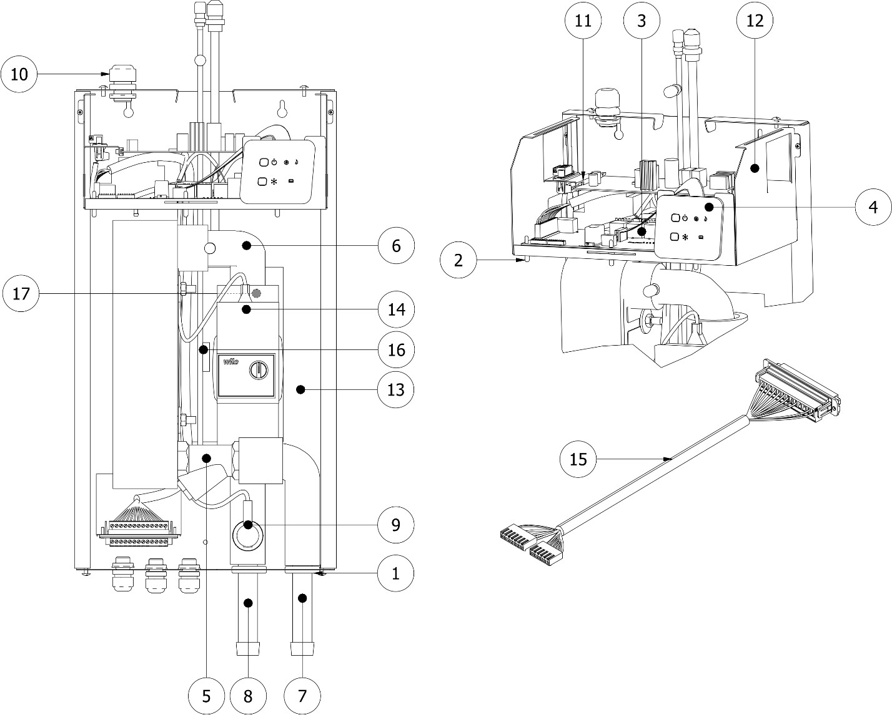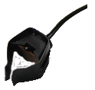

19

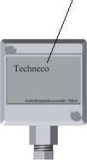

18

|  |  |  |
| --- | --- | --- |
| **Parts list** | | |
|  | **Article** | **Article number** |
| **1** | Transit tulip 25-37 | 60303 |
| **2** | Circuit board spacer 9.5mm | 60323 |
| **3** | Related to Elga Main Board 2.0: | EN-60531A |
| **4** | Elga display | EN-60531b |
| **5** | Y-filter 1"x1" | 60537 |
| **6** | Hydraulic line 1 incl. 2x utility and insulation | EN-60538A |
| **7** | Hydraulic line 2 incl. utility and insulation | EN-60538b |
| **8** | Hydraulic line 3 incl. utility and insulation | EN-60538C |
| **9** | Sika flow sensor VK3 DN20 | 60561 |
| **10** | Plastic swivel M16 | 60569 |
| **11** | Toshiba Holder Print | 60573 |
| **12** | Related to Circuit Board Holder Elga 5.0: | 60651 |
| **13** | Back plate Elga | 60565 |
| **14** | Pump Elga Yonos Para RS25-6-RKA MC 130 6 | 60745 |
| **15** | Cable for extra functionality | 60509 |
| **16** | Temperature sensor TCJ temp. refrigerant | 60069 |
| **17** | Temperature sensor TC2 temp. condenser off | 61055 |
| **18** | TBU outdoor sensor | 61055 |
| **19** | NTC Sensor 250cm Cable (10kΩ) | 60531d |

# Dimensions

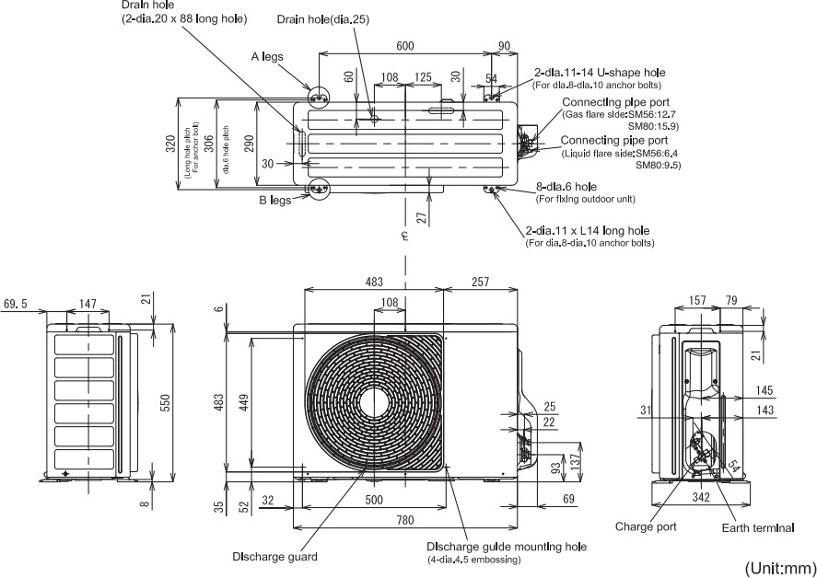

# L:\Elga\Handleidingen\beheer\Gegevens t.b.v. handleiding\1_elga_binnen-unit_elektrisch.pngElectrical diagram + resistors NTC sensors

##### Table 17-1 NTC temperature sensors resistance table 10 kOhm\*

|  |  |  |  |  |  |  |  |  |  |  |  |  |  |  |  |
| --- | --- | --- | --- | --- | --- | --- | --- | --- | --- | --- | --- | --- | --- | --- | --- |
| Temperature (°C) | 5 | 10 | 15 | 20 | 25 | 30 | 35 | 40 | 45 | 50 | 55 | 60 | 65 | 70 | 75 |
| Resistance (kΩ) | 26,1 | 20,3 | 15,9 | 12,6 | 10 | 8.0 | 6,5 | 5,13 | 4,3 | 3,6 | 3,0 | 2,5 | 2,1 | 1,7 | 1,5 |

\* applies to the NTC temperature sensors supply and return.

# Installation diagrams

## K1OpenTherm central heating boiler + Honeywell Touch modulation thermostat

## K2On/off central heating boiler + Honeywell Touch modulation thermostat

## K3OpenTherm central heating boiler + other OpenTherm thermostat

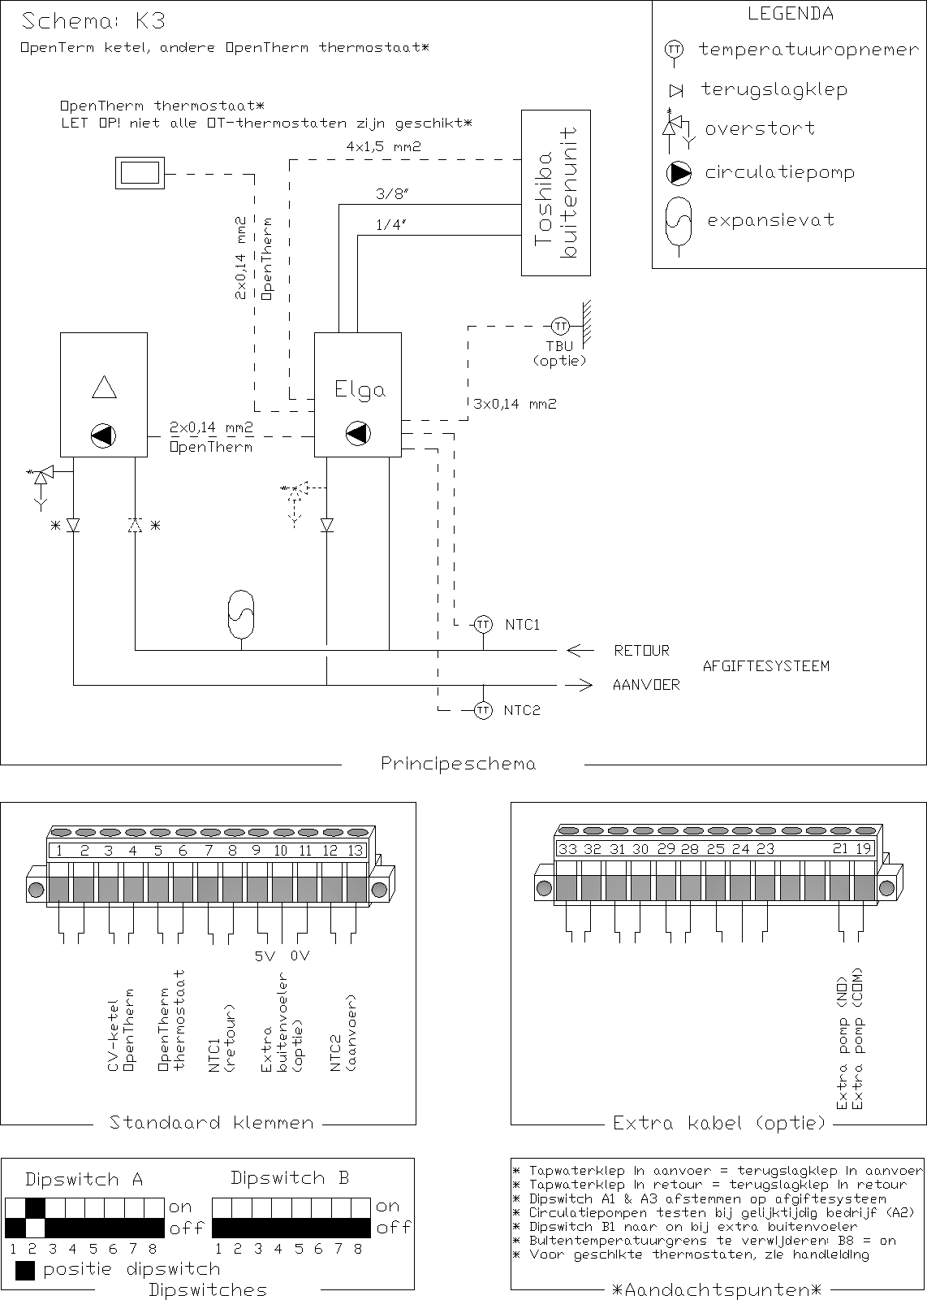

## K4On/off central heating boiler + other OpenTherm thermostat

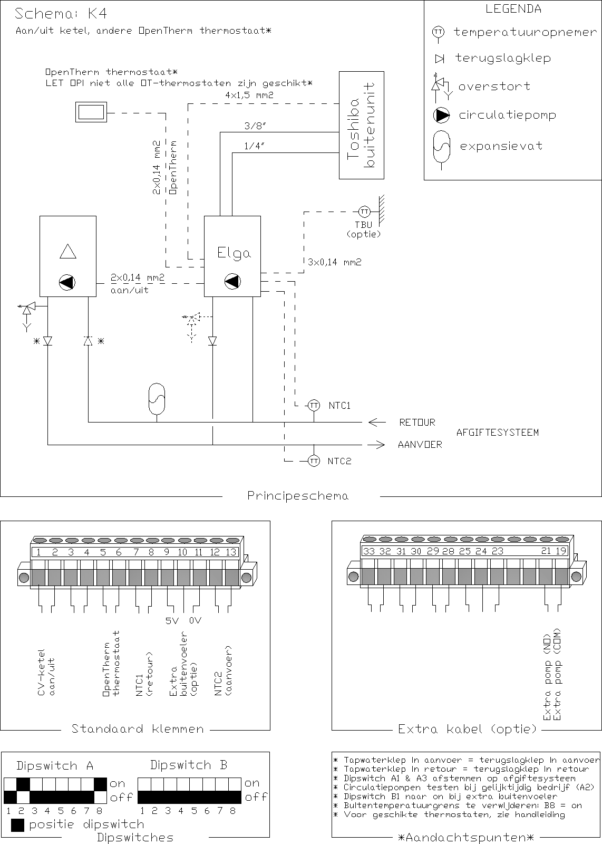

## K5OpenTherm central heating boiler + weather-dependent control

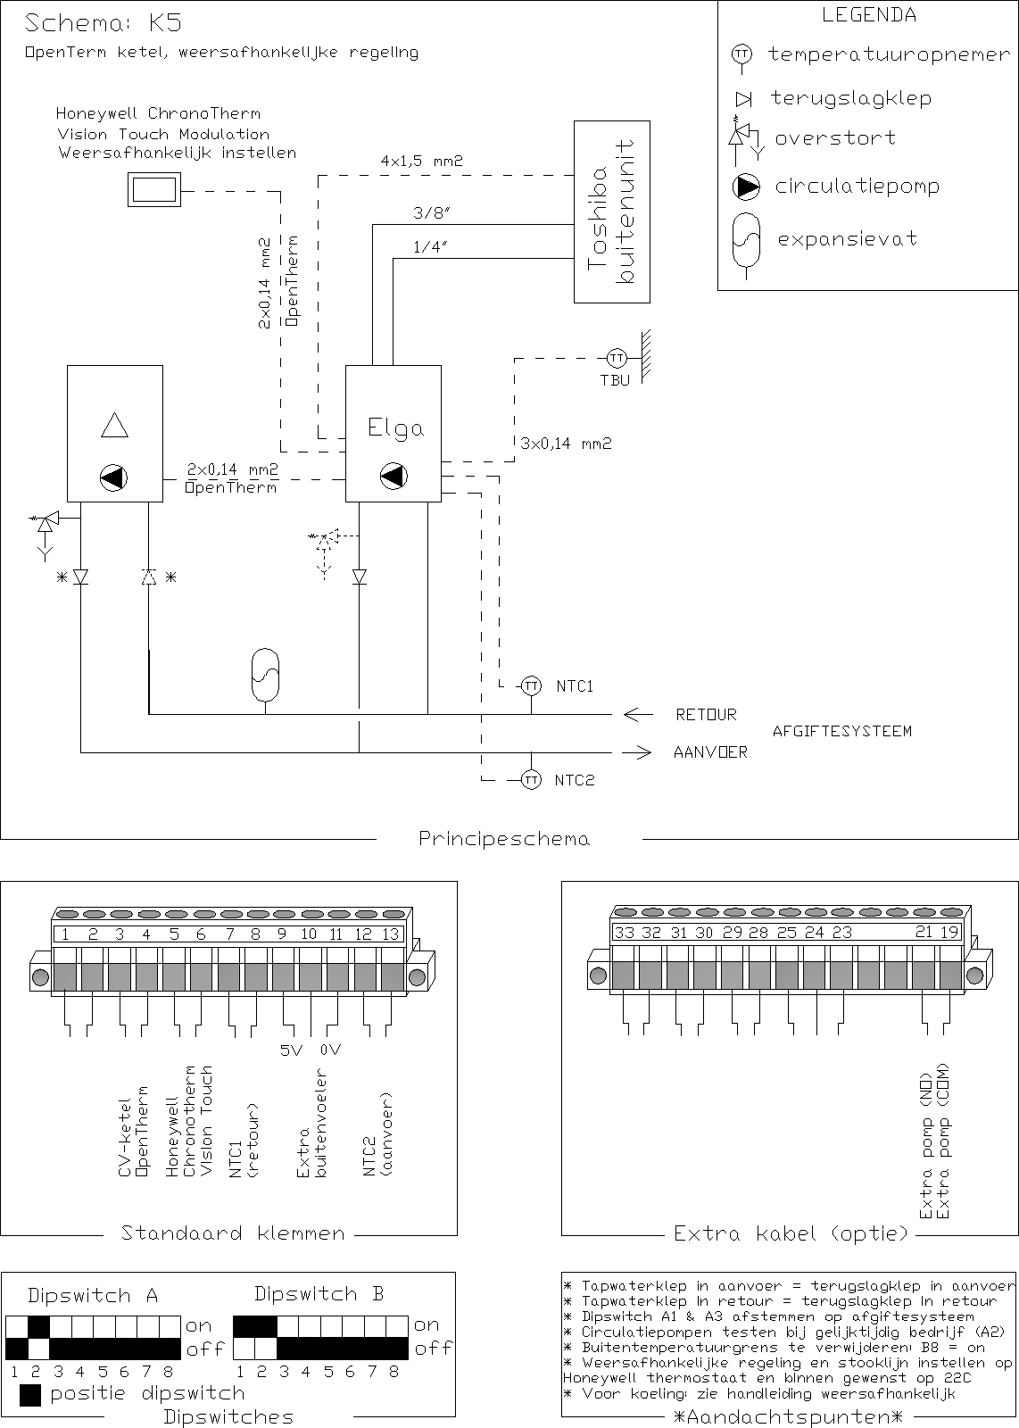

## K6On/off central heating boiler + weather-dependent control

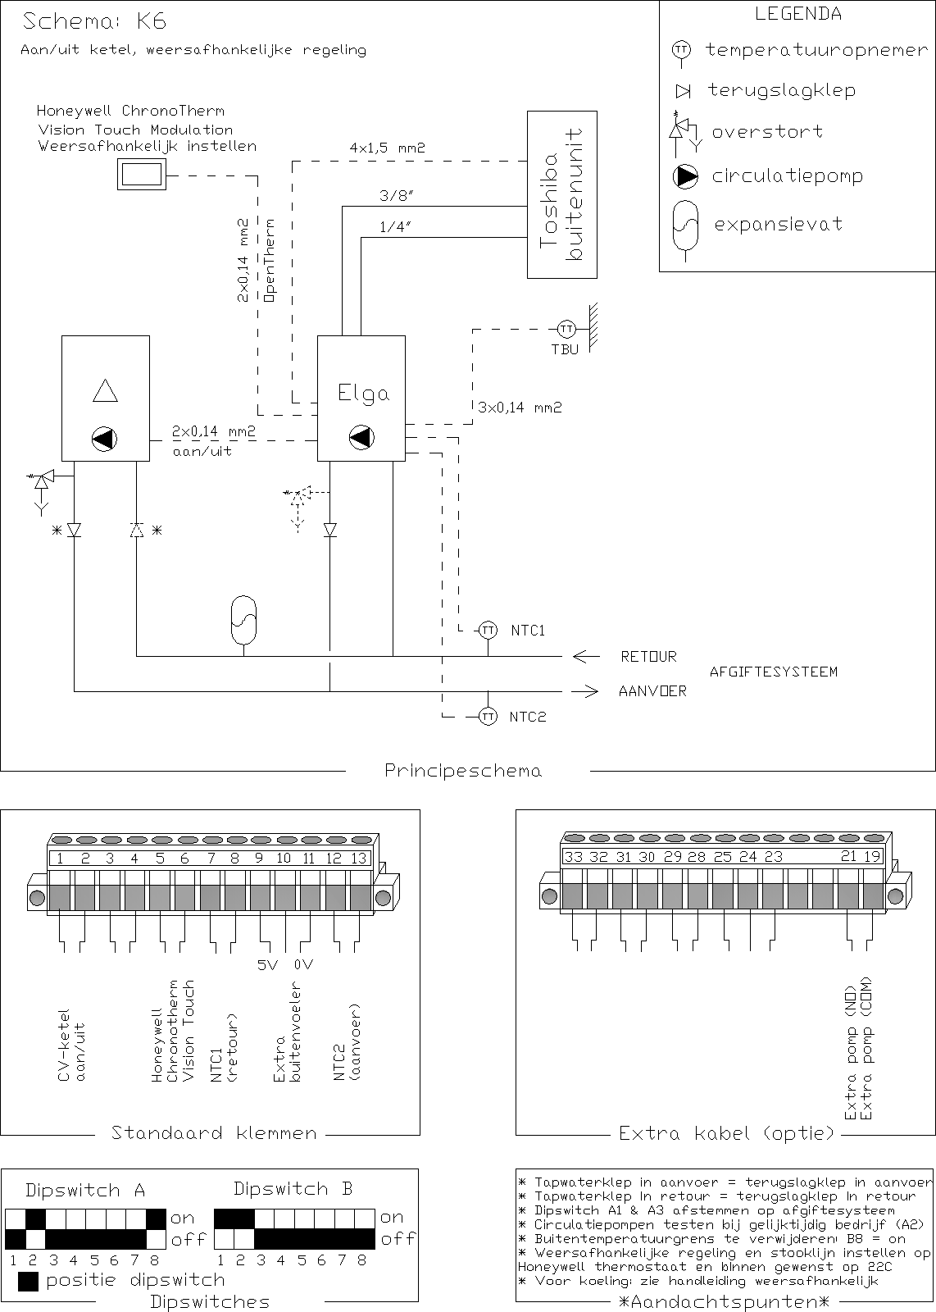

## K7OpenTherm central heating boiler + zone control general

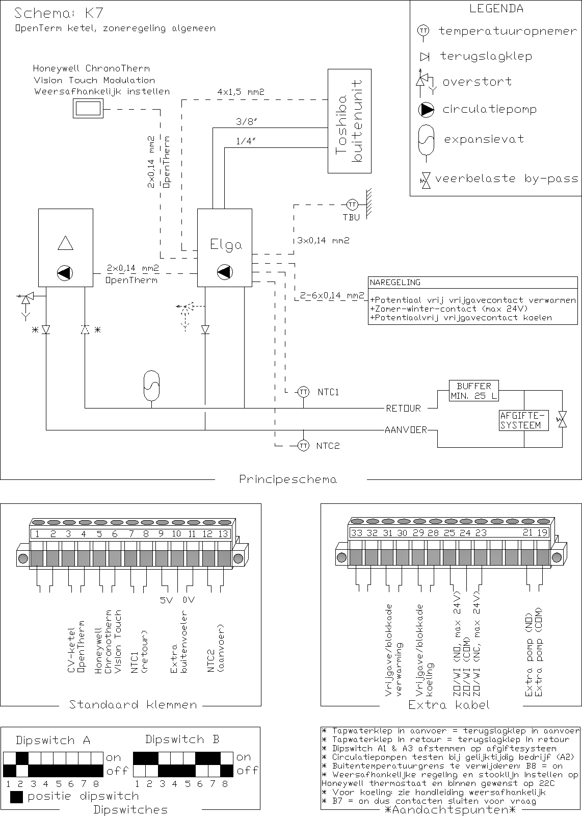

## K8On/off central heating boiler + zone control general

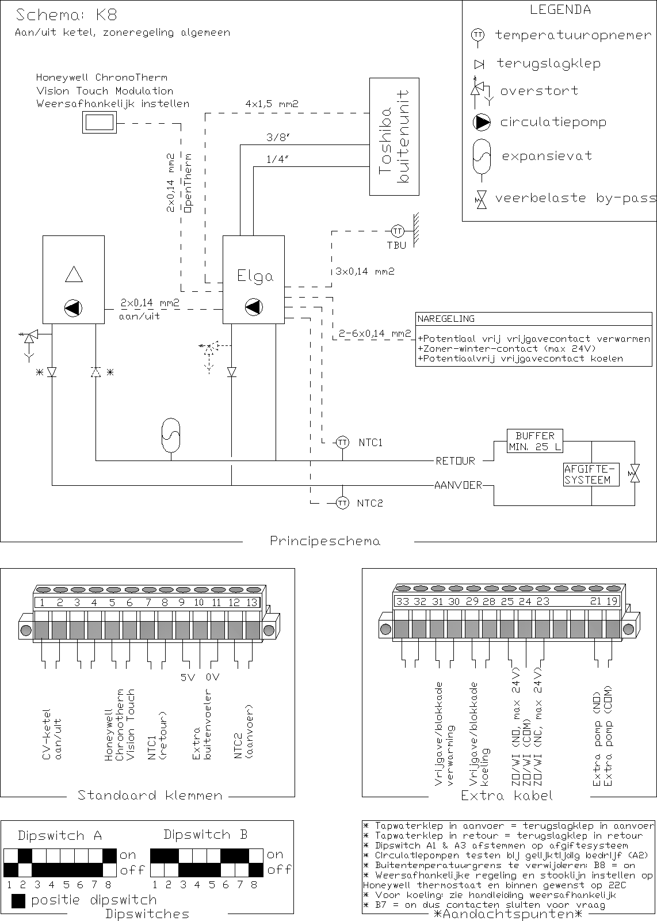

## K9OpenTherm central heating boiler + zone control Honeywell HCE20

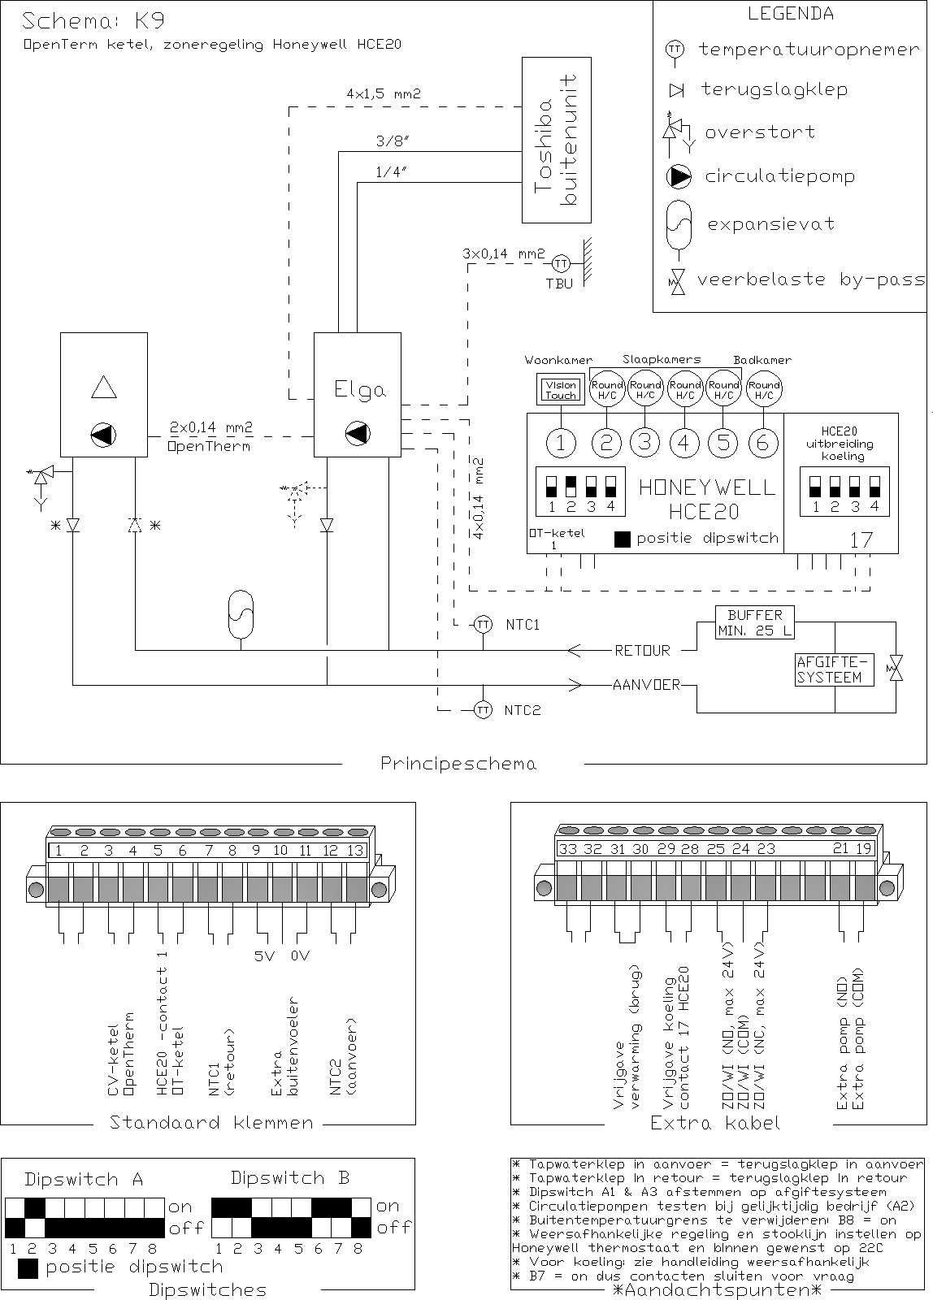

## K11OpenTherm central heating boiler + zone control Danfoss CF2+

## K13OpenTherm central heating boiler + zone control Honeywell EvoHome

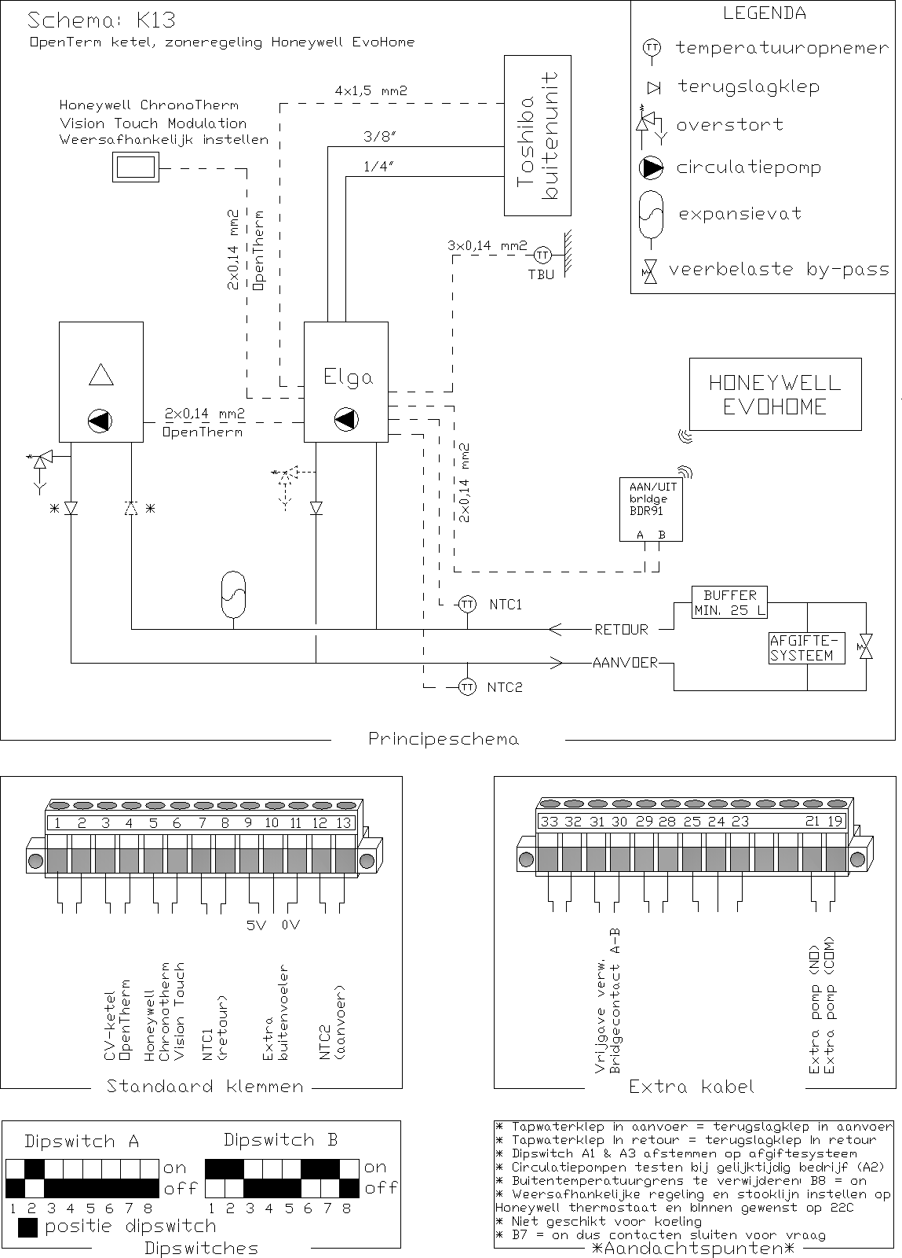

## K14On/off central heating boiler + zone control Honeywell EvoHome

## K15CV boiler + Elga with open distributor in series

## SV1City heating + Honeywell Touch modulation thermostat

## SV2 Distric heating + other OpenTherm thermostat

## SV3City heating + weather-dependent control

## SV4City heating + zone control in general

## SV5City heating + zone control Honeywell HCE20

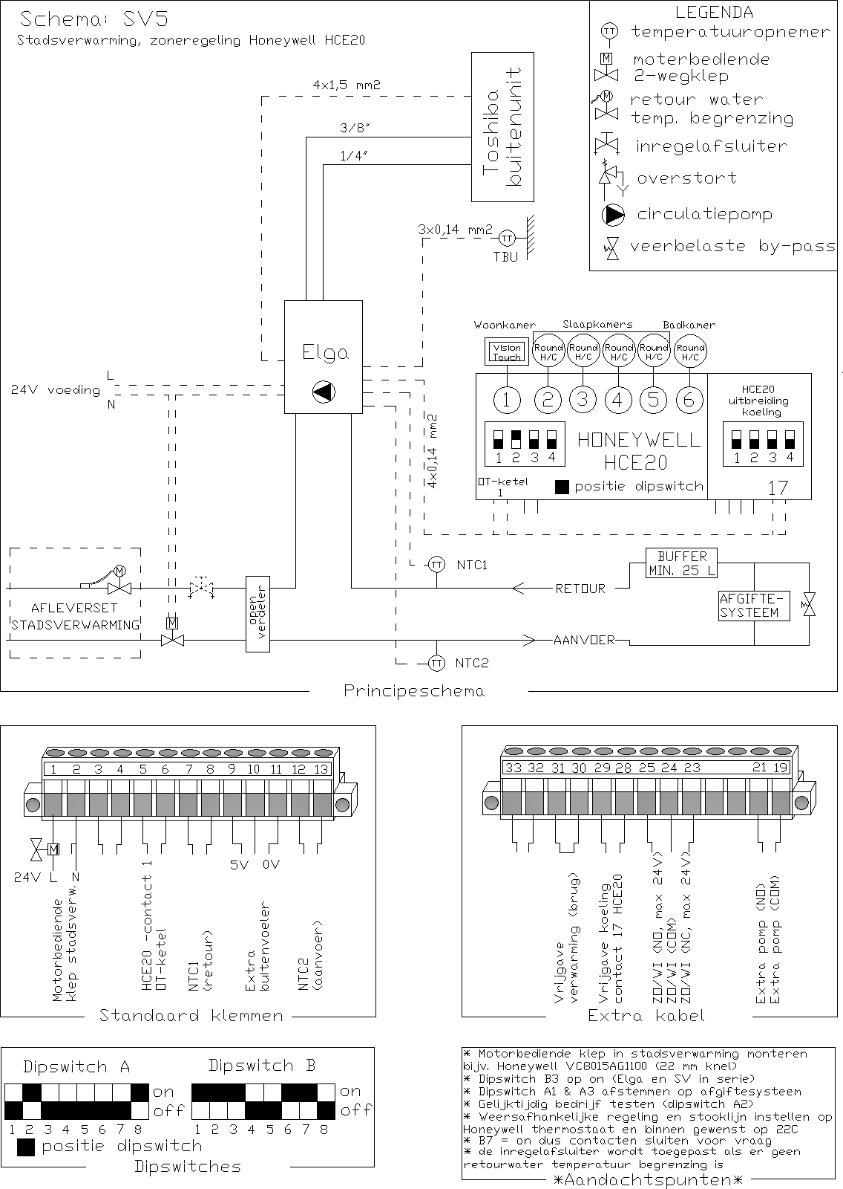

## SV6City heating + Zone control Danfoss CF2+

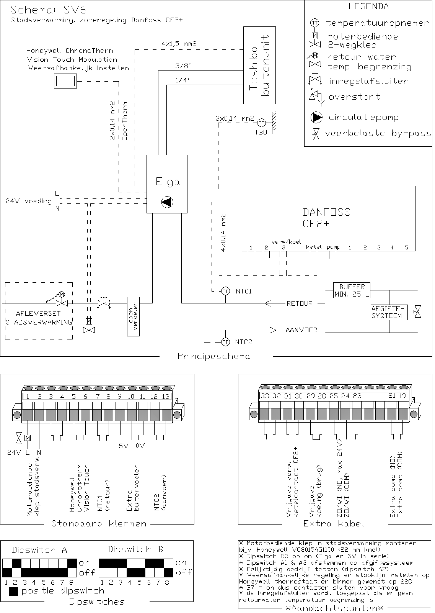

## SV7City heating + Zone control Honeywell EvoHome

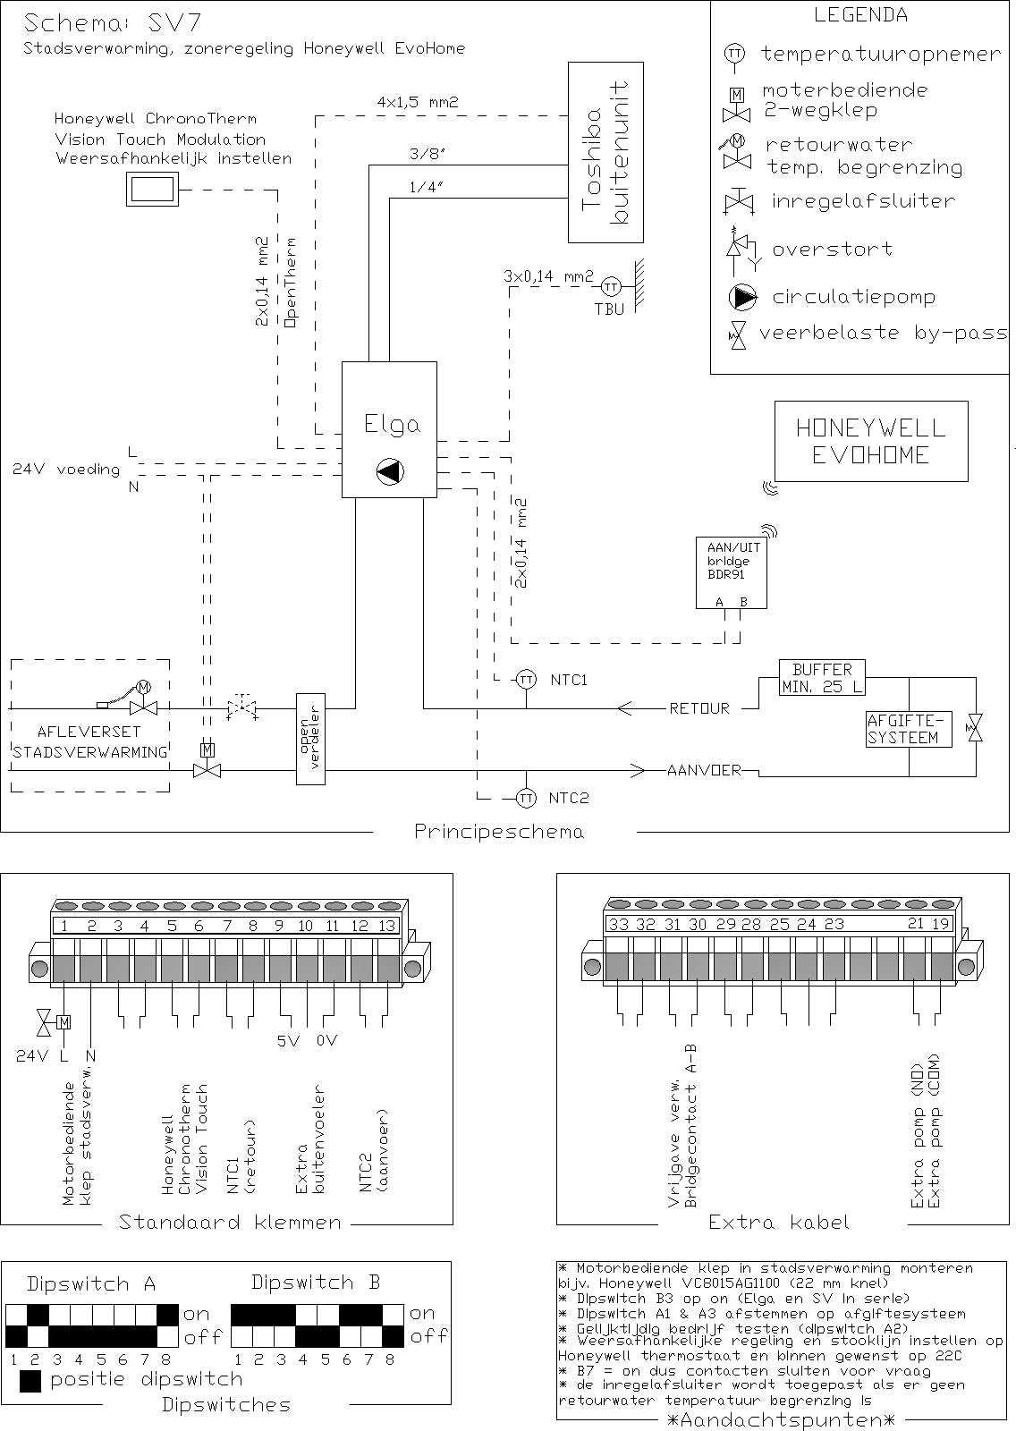

## Elga and boiler with separate boiler for tap water (hydraulic)

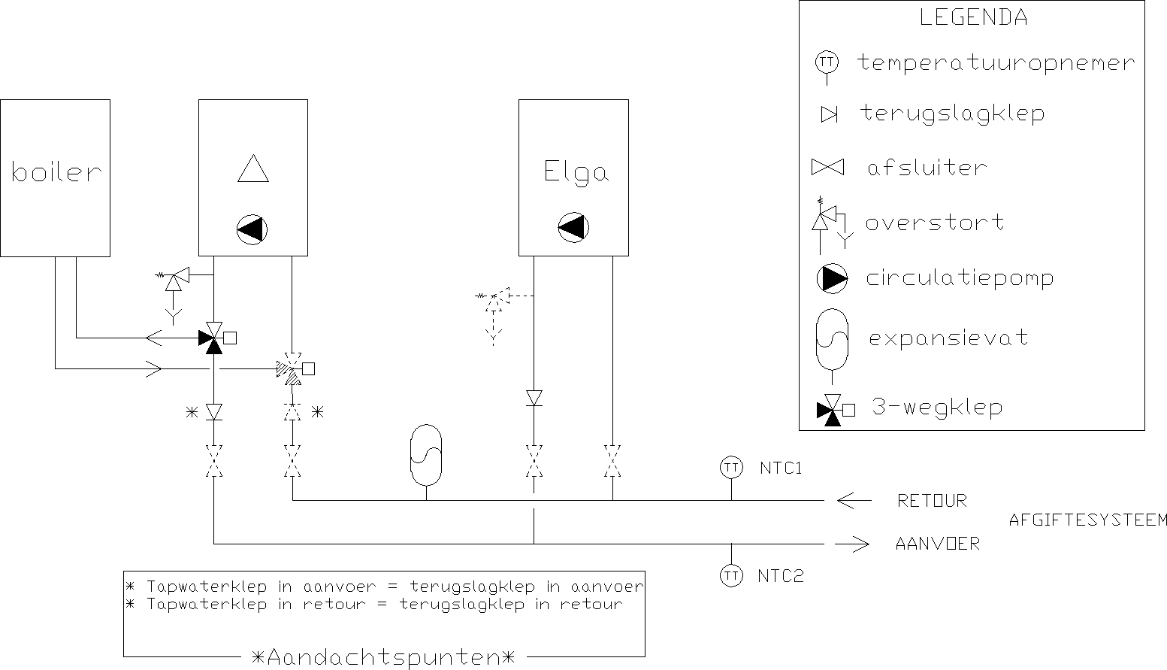

# Parameter list Honeywell Touch thermostat

## Thermostat installer menu

|  |  |  |
| --- | --- | --- |
| **Code** | **Definition** | **Recommended setting** |
| **0009** | **ADAPT WARMING UP**  The Elga does not support adaptive heating | 0 |
| **0011** | **EXTRA OPTION**  An additional outdoor temperature sensor can be connected to the thermostat. This is not necessary, this outside temperature sends the Elga via OpenTherm | 0 |
| **0012** | **OPTIMAL COMFORT** | 0 |
| **0013** | **HEAT COOLING** | 1 |
| **0016** | **BOILER FAULT CODE**  Here the fault code of the Elga can be read out. For the fault code list see chapter [0](#_bookmark45) |  |
| **0017** | **SUPPLY TEMP**  Here the current measured supply temperature of the system can be read out (NTC2) |  |
| **0019** | **RETURN TEMP**  Here the current measured return temperature of the system can be read out (NTC1) |  |
| **0020** | **REQUESTED TOV**  This is the desired supply temperature that the thermostat calculates. The Elga only reacts to this value if the Elga is set as Weather dependent. See chapter regulation |  |
| **0021** | **CURRENT**  Current modulation level of the outdoor unit (% of maximum power) |  |
| **0029** | **SPACE WEATHER OFF**   1. - Control based on the measured room temperature. 2. - Control only based on outside temperature, only set if the Elga is also set to weather dependent | 0 or 1 |
| **0030** | **HEATING LINEINST**  Heating line for weather-dependent control  5 - 8 - Only underfloor heating (distributor without mixing)  10 - 20 - Radiators or radiators and underfloor heating (mixing distributor with pump) | 5 to 20 |

## Elga parameters menu

Read only

|  |  |  |
| --- | --- | --- |
| **Parameter** | **Definition** | **Unit** |
| **P4.** | Supply temperature (NTC2) | °C |
| **P5** | Return temperature (NTC1) | °C |
| **P8** | Refrigerant condenser | °C |
| **P9.** | Refrigerant condenser off | °C |
| **P23.** | Compressor status | - |
| **P33.** | Firmware version | - |
| **P86.** | Toshiba print fault code | - |
| **P87.** | Fault code OpenTherm central heating boiler | - |
| **P89.** | Status central heating boiler | - |
| **P90.** | Status Elga | - |
| **P91.** | Status dipswitch row A | - |
| **P92.** | Status dipswitch row B | - |
| **P93.** | Cooling status | - |

Read out and set up

|  |  |  |  |  |
| --- | --- | --- | --- | --- |
| **Parameter** | **Definition** | **Unit** | **Range** | **Factory setting** |
| **P62.** | Reduce heat pump cut-off temperature from 4°C (calculation method: 4°C – P62 = cut-off temperature) | K | 0... 20 | 0 |
| **P63.** | Switch-on outside temperature limit central heating boiler lower (calculation method: 40 °C – P63 = limit outside temperature) Above the outside temperature limit, the boiler does not switch on | K | 0... 50 | 0 |
| **P64.** | Heating overrun time internal pump | seconds | 10... 240 | 60 |
| **P65.** | Heating the overrun time external pump | seconds | 10... 240 | 60 |
| **P66.** | Overrun time internal pump cooling | seconds | 120... 240 | 120 |
| **P67.** | Cooling the overrun time of the external pump | seconds | 120... 240 | 120 |
| **P68.** | Lead time internal and external pump | seconds | 10... 240 | 30 |
| **P70.** | Setpoint reduced indoor temperature | °C | 1... 30 | 19 |
| **P71.** | Hysteresis cooling (top) | K | 1... 5 | 3 |
| **P72.** | Hysteresis cooling (bottom) | K | 1... 3 | 1 |
| **P73** | Minimum supply temperature cooling (at Tbuiten = 21°C) | °C | 15... 25 | 17 |
| **P74.** | Maximum supply temperature cooling (at Tbuiten = 30°C) | °C | 15... 25 | 21 |
| **P75.** | Minimum supply temperature heating RAD-LOW (at Tbuiten = 20°C) | °C | 20... 90 | 40 |
| **P76.** | Maximum supply temperature heating RAD-LOW (at  Tbuiten = -10°C) | °C | 20... 90 | 70 |
| **P77.** | Waiting time hibernate/sleep mode (number of hours no question) | Hours | 1... 24 | 10 |
| **P78.** | Minimum boiler response time (depending on outside temperature) (calculation method: minimum on time = (20 - Tbuiten) \* setting,  so at Tbuiten = +10°C the minimum time is (20-10)\*20 = 200 s) | SEC/K | 0... 60 | 20 |
| **P79.** | Minimum boiler out time (depending on outside temperature) (calculation method: minimum downtime = |( -10 - Tbuiten)| \* setting, so at Tbuiten = -5°C the minimum time is | (-10--5)|\*20 = 100 s) | SEC/K | 0... 60 | 20 |
| **P80.** | Upgrade outdoor unit to return temperature | °C | 25... 43 | 43 |
| **P81.** | Keep outdoor unit the same until return temperature | °C | 25... 45 | 45 |
| **P82.** | Outdoor unit revs back to and from above return temperature | °C | 25... 47 | 47 |
| **P83.** | The fictitiously calculated supply temperature at which the boiler is controlled faster in weather-dependent | °C | 30... 90 | 60 |
| **P84.** | Switch on degree minutes central heating boiler in thermostatic operation | K\*min | 10... 120 | 30 |
| **P85.** | Test mode  1 = Circulation pumps on  2 = Circulation pumps + Heat pump on  3 = Circulation pumps + Heat pump + central heating boiler to 4 = Circulation pumps + Heat pump in cooling mode | - | 0... 4 | 0 |
| **P88.** | Smart grid control  0= No smartgrid functions active 1= normal use  2= Only Block Elga for heating/cooling | - | 0... 255 | 0 |